
FUTURE BUSINESS ANALYST SEASON 6
ROUND 2 BUSINESS ANALYTICS REPORT
DNSE Securities
Joint Stock Company
Team | KTQT FTUers
Date | 27 September 2026

Executive summary
DNSE Securities leads Vietnam's brokers in account growth. Zero-fee trading on the Entrade X app, together with Margin Deal, Future X and the Ensa assistant, brought it one in five of the country's new securities accounts in 2025 and more than 1.7 million accounts by mid-2026, 12.3 per cent of the market. Customer money has not followed. DNSE holds 2.3 per cent of the cash investors keep at brokers, 1.4 per cent of margin lending and 0.6 per cent of industry profit. In December 2025, 5.7 per cent of its accounts used at least one product and 1.8 per cent held net assets of VND 10 million or more.
The funding gap is costly. Brokerage revenue has been below its direct cost for 16 consecutive quarters, and annualised return on equity fell to 3.8 per cent in the first half of 2026. Without a parent bank, DNSE borrows short term against pledged deposits that tie up 38 per cent of its assets. Between 2021 and 2025, accounts grew 33.8 times while core pre-tax profit grew 2.7 times. Platform and overhead costs of about VND 198 billion in 2025 fall on few funded customers, about VND 7.3 million a year for each account with VND 10 million or more, and at the industry's average cash per account DNSE would hold 5.4 times its current investor cash.
Three causes explain the gap, with different strengths of evidence. DNSE's tools attract young traders with little capital. Trust fails at the first deposit, since complaints about deception, sign-up bonus terms and a closure fee appear in 37 per cent of DNSE's negative reviews since 2025, against 8 per cent at VPS, and the rating of substantive reviews fell from 4.15 in 2024 to 2.38 in 2025. Most important, no DNSE product turns a salaried customer's intention to invest into regular deposits, although 22.1 million Vietnamese adults hold an account without saving formally.
The core problem is the funding gap among existing accounts, and trust is a condition of any solution. We recommend Payday Portfolio, a goal-based investing plan built from products DNSE already runs. Ensa proposes one of three model portfolios inside DNSE's licensed advisory service, and the customer confirms it. A standing order then moves part of each salary into a virtual account in the customer's own name, and each contribution is invested in the asset class furthest below its target weight. Free commitment tiers reward three, six and twelve consecutive contributions, with one skipped month a year allowed, and trust controls remove the closure fee and conditional sign-up rewards. DNSE's wider technology should be organised around customer balances. ZaloPay round-ups become an entry route for customers without a salary, rule-based strategies become additional model portfolios, and a dashboard shows where client cash is held. A credit line secured on savings is not recommended because it conflicts with lending rules.
In the base case, 150,000 savers contributing VND 1.5 million a month would hold VND 2.8 trillion after 18 months, 1.4 times DNSE's current investor cash, and tier interest would cost at most VND 5.6 billion a year. Customer segments and intent remain hypotheses because DNSE does not publish customer-level data. Appendix F sets out a randomised pilot with 20,000 dormant customers. Its headline KPI is the number of accounts holding VND 10 million or more, 27,100 at the end of 2025, with a target of 85,000 within 18 months.

Table of contents
1. Introduction 5
1.1 DNSE and its business model 5
1.2 Vietnam context and the market gap 5
1.3 Business question and scope 6
2. Findings of observations 7
2.1 Evidence base and method 7
2.2 Finding 1. Accounts are opened but rarely funded 7
2.3 Finding 2. Free trades lose money 8
2.4 Finding 3. Lending growth is capital-intensive 8
2.5 Finding 4. Idle accounts make the platform a fixed cost 9
2.6 Finding 5. Trust complaints are specific to DNSE 9
2.7 Finding 6. Saving products exist but reach few customers 10
3. Discussion and main analysis 11
3.1 From symptom to root cause 11
3.2 Account growth has not produced balances or profit 11
3.3 Trust fails at the point of deposit 12
3.4 Intention without a route to investment 12
3.5 Alternative explanations 12
3.6 Core problem and design conditions 13
4. Recommendations 13
4.1 Payday Portfolio 13
4.2 How Payday Portfolio works 13
4.3 How Payday Portfolio resolves the core problem 14
4.4 Extending DNSE's technology ecosystem 15
5. Conclusion 16
Appendices 17
Appendix A. Data preparation and quality 17
Appendix B. DNSE financial data 19
Appendix C. Market and peer data 22
Appendix D. Customer review analysis 23
Appendix E. Findex segment analysis 25
Appendix F. Assumptions, sensitivity and alternative explanations 27
Appendix G. Regulatory basis and technology proposals 30
References 31

List of figures and tables
Figures
Figure 1. Returns on a saver's idle cash, September 2026 5
Figure 2. Investor cash held at brokers, third quarter of 2025 = 100 5
Figure 3. Activity, balances and product use among DNSE accounts, December 2025 7
Figure 4. DNSE's share of eight markets, 2025 to mid-2026 7
Figure 5. Brokerage revenue against direct brokerage cost, by quarter 8
Figure 6. Funding structure of DNSE and four peers, second quarter of 2026 8
Figure 7. Platform and overhead cost proxy and the accounts that carry it 9
Figure 8. Complaint themes in negative Google Play reviews 10
Figure 9. Vietnamese adult segments by digital habit and formally held surplus 10
Figure 10. Root-cause tree for unfunded accounts 11
Figure 11. Accounts, revenue, platform cost and core profit, 2021 = 1 12
Figure 12. How Payday Portfolio works 13
Figure 13. Contributions needed to reach VND 10 million, before investment returns 14
Figure 14. DNSE's technology ecosystem organised around customer balances 15
Tables
Table 1. The problem statement and the Payday Portfolio response 15

1. Introduction

1.1 DNSE and its business model
DNSE Securities began in 2007 as Dai Nam Securities. Rebuilt by the Encapital group as a branchless, technology-led broker, it listed on HOSE in July 2024 (CafeF, 2024). Its Entrade X app offers free share trading for life, derivatives, deal-by-deal margin loans (Margin Deal) and an artificial intelligence assistant (Ensa). Two products hold customer money. The Never-Sleeping Account, an idle-cash account launched in June 2025, pays 1.8 to 4.3 per cent a year, and Golden Egg sells bonds from VND 1 million (DNSE Securities, 2026b, 2026c). In the first half of 2026, margin interest supplied 40 per cent of operating revenue and brokerage 26 per cent (Table B1).

1.2 Vietnam context and the market gap
Three conditions shape how DNSE's data should be read. First, banks pay savers more, and 12-month deposit rates at state banks reached about 6.8 per cent in 2026 (VnEconomy, 2026; VietnamNet, 2026). A typical DNSE customer earns 2.1 to 2.3 per cent on idle cash, below inflation of 4.45 per cent (Figure 1).
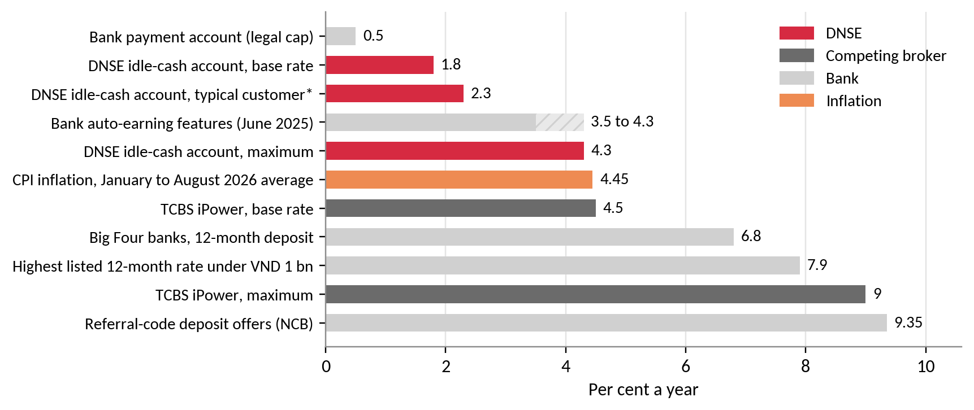
Figure 1. Returns on a saver's idle cash, September 2026
Source: DNSE Securities (2025, 2026b); TCBS (2026); VietnamNet (2026); VnExpress (2026b); Bao Dau Thau (2026).
Second, investor cash at brokers fell 38 per cent in three quarters (VnEconomy, 2026). DNSE's cash fell in the same proportion (Figure 2), so its recent decline is cyclical, while its small share of cash is structural. Third, bank-owned brokers supplied 62 per cent of lending growth in the second quarter of 2026 (Vietstock, 2026c), so DNSE cannot compete on the price of credit. Banks must also open their application interfaces to third parties by March 2027 (State Bank of Vietnam, 2024).
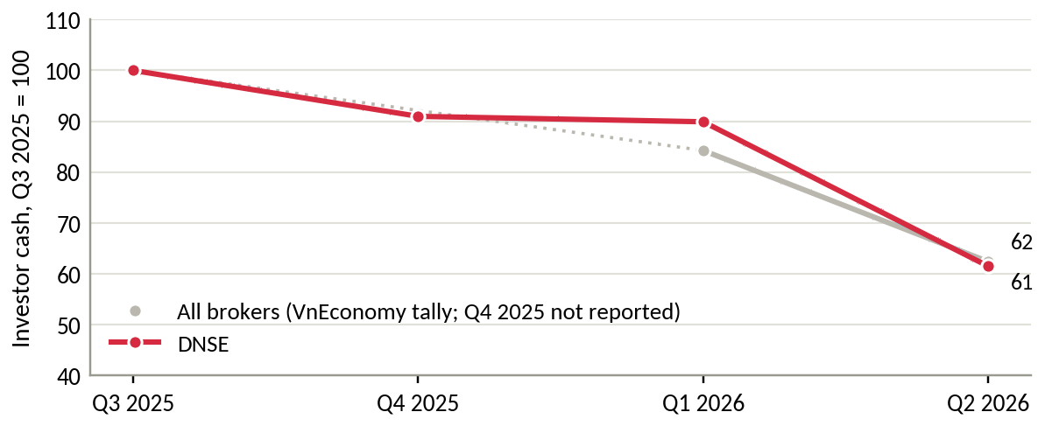
Figure 2. Investor cash held at brokers, third quarter of 2025 = 100
Source: VnEconomy (2026); DNSE filings. Industry total for Q4 2025 not reported.
The market gap lies between banks, which hold salaries but offer little investment, and brokers, whose products start after a customer decides to invest (Table C3).

1.3 Business question and scope
Business question. Why do DNSE's accounts not become funded relationships, and which initiative would convert them most cost-effectively within DNSE's capabilities and licences? The scope covers retail customers from account opening to regular funding.

2. Findings of observations

2.1 Evidence base and method
The evidence combines DNSE's filed statements from 2018 to mid-2026, reconciled to the reviewed half-year statements, its 2025 annual report, peer and industry data, 3,299 app reviews of DNSE, VPS and FPTS, and Global Findex 2024 data (Table A1). Spam, 23 per cent of DNSE's Google Play reviews, was removed with tested rules (Appendix A). DNSE publishes no customer-level data, so statements about segments and intent are labelled as hypotheses.

2.2 Finding 1. Accounts are opened but rarely funded
DNSE opened 518,514 accounts in 2025, one in five of Vietnam's new accounts, and ended the year with 1,512,920. In December 2025 only 85,739 (5.7 per cent) used any product, and 27,100 (1.8 per cent) held net assets of VND 10 million or more (Figure 3).
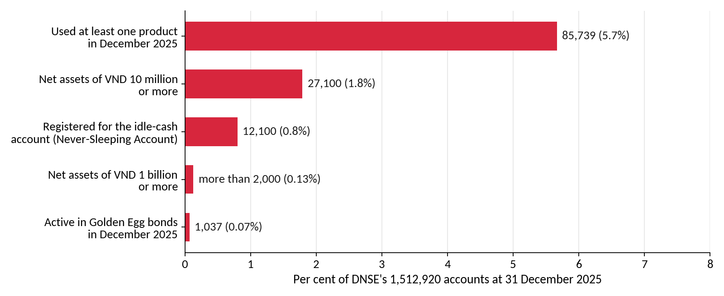
Figure 3. Activity, balances and product use among DNSE accounts, December 2025
Source: DNSE Securities (2026c).
The closer a measure sits to money, the smaller DNSE becomes (Figure 4). It holds 12.3 per cent of accounts but 2.3 per cent of investor cash, 1.4 per cent of margin lending and 0.6 per cent of industry profit. VPBankS and TCBS lend 8 and 12 times more per account, and VPS, which also has no parent bank, lends 5 times more (Table C2).
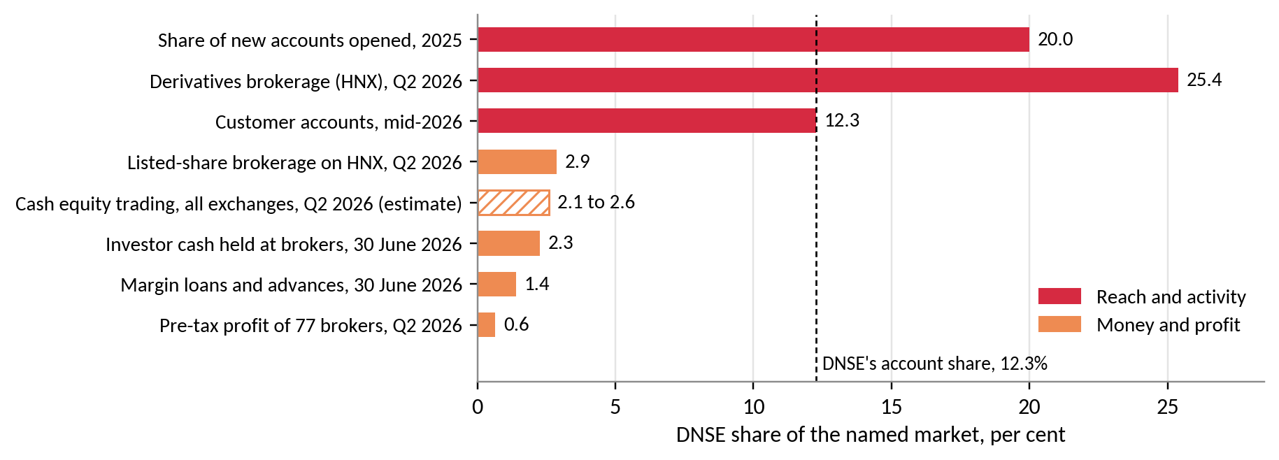
Figure 4. DNSE's share of eight markets, 2025 to mid-2026
Source: Table C1. Hatched bar estimated.
Insight: DNSE's acquisition works. Value is lost between opening an account and the first deposit.

2.3 Finding 2. Free trades lose money
Pre-tax profit excluding proprietary trading has stayed between VND 128 and 221 billion a year since 2022 (Table B1). Brokerage revenue has been below its direct cost for 16 consecutive quarters, a cumulative shortfall of VND 190 billion (Figure 5). Annualised return on equity fell to 3.8 per cent in the first half of 2026, below a 12-month deposit at a state bank.
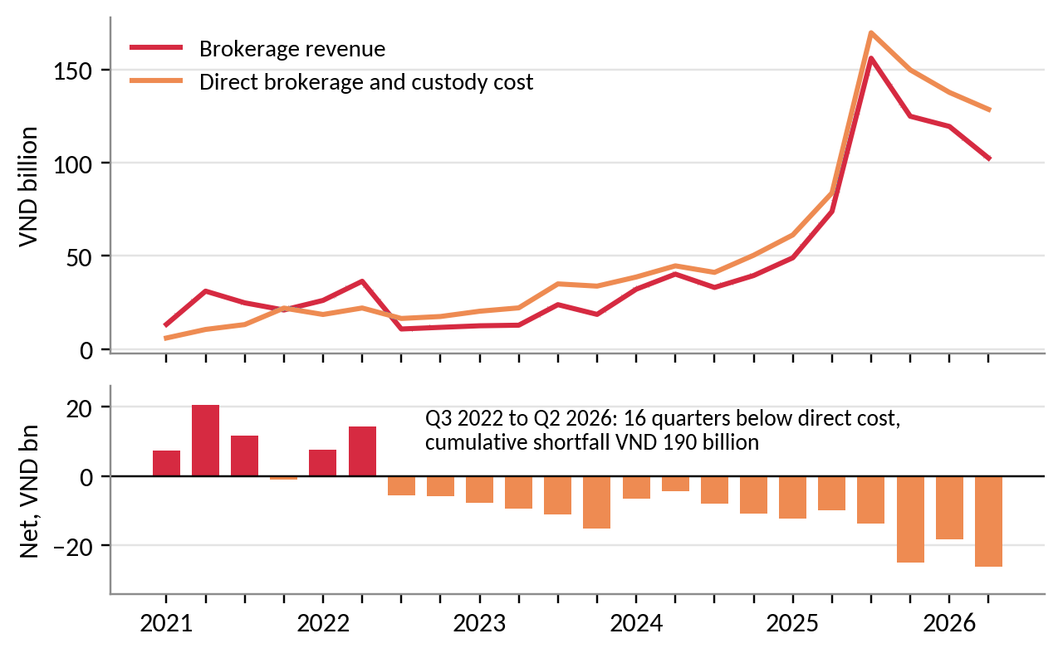
Figure 5. Brokerage revenue against direct brokerage cost, by quarter
Source: DNSE filings via Vietcap Securities (2026).
Insight: More trading does not raise profit, so profit growth has to come from customer balances.

2.4 Finding 3. Lending growth is capital-intensive
DNSE's estimated cost of funds rose from 3.6 per cent in mid-2024 to 6.5 per cent in the second quarter of 2026. Without a parent bank, it borrows short term against pledged deposits and bonds, which make up 37.6 per cent of its assets against 4 to 9 per cent at four large peers (Figure 6). Loans stood at 116 per cent of equity against a ceiling of 200 per cent, so DNSE has room to lend. It lacks customers with assets to borrow against.
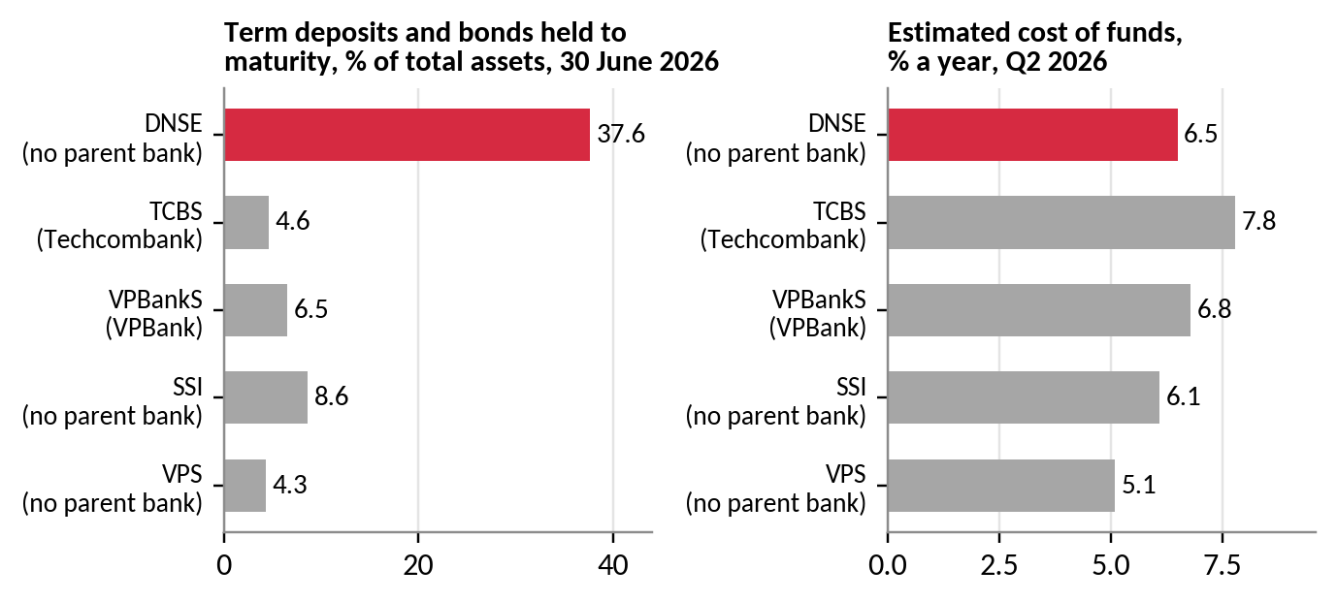
Figure 6. Funding structure of DNSE and four peers, second quarter of 2026
Source: filed statements via Vietcap Securities (2026); authors' calculations.
Insight: Fee income on customer balances uses less capital than margin growth, and margin demand follows customer assets.

2.5 Finding 4. Idle accounts make the platform a fixed cost
A proxy of staff costs, outsourced services and depreciation rose 12.5 times between 2021 and 2025, to VND 198 billion, while revenue rose 8.1 times (Table B3). The proxy equals VND 0.13 million per account but VND 7.3 million per account holding VND 10 million or more (Figure 7). It may include other overheads, so it indicates trend and scale only.
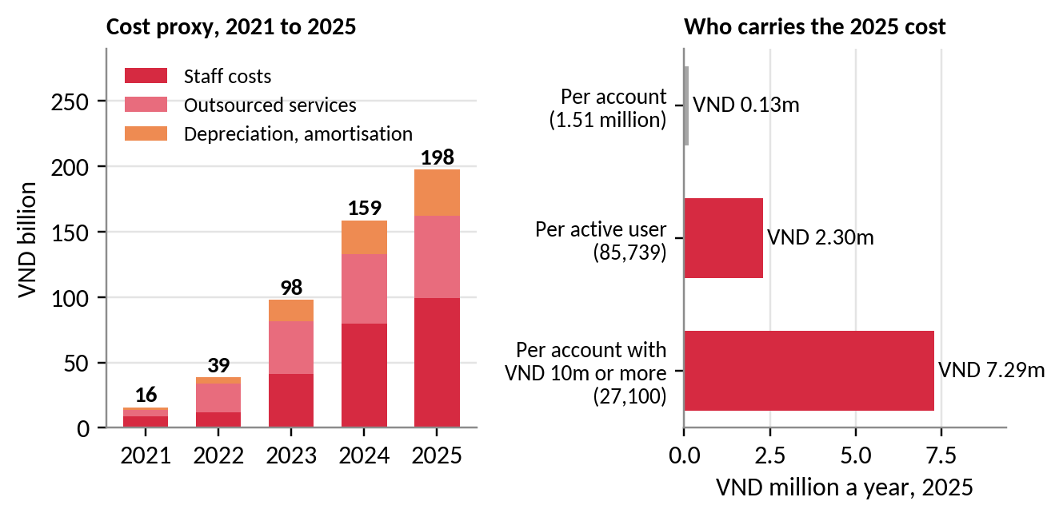
Figure 7. Platform and overhead cost proxy and the accounts that carry it
Source: DNSE filings; DNSE Securities (2026c); authors' calculations.
Insight: Fewer than 2 in 100 accounts carry the platform's cost, so funding existing accounts is the cheapest way to lower unit costs.

2.6 Finding 5. Trust complaints are specific to DNSE
In 278 negative DNSE reviews on Google Play, crashes and login failures appear in 27 per cent and identity checks in 21 per cent. Complaints about deception, sign-up bonus terms and the closure fee appear in 24 per cent but attract 43 per cent of helpful votes (Figure 8). The most-endorsed reviews describe a VND 100,000 reward that required a VND 2 million deposit and a VND 100,000 closure fee. Since 2025, reliability complaints have been at least as common at VPS (46 per cent) as at DNSE (38 per cent), yet VPS lends five times more per account. Trust complaints, however, reach 37 per cent at DNSE against 8 per cent at VPS and 1 per cent at FPTS. A regulatory fine in August 2026 adds to these doubts (Market Times, 2026).
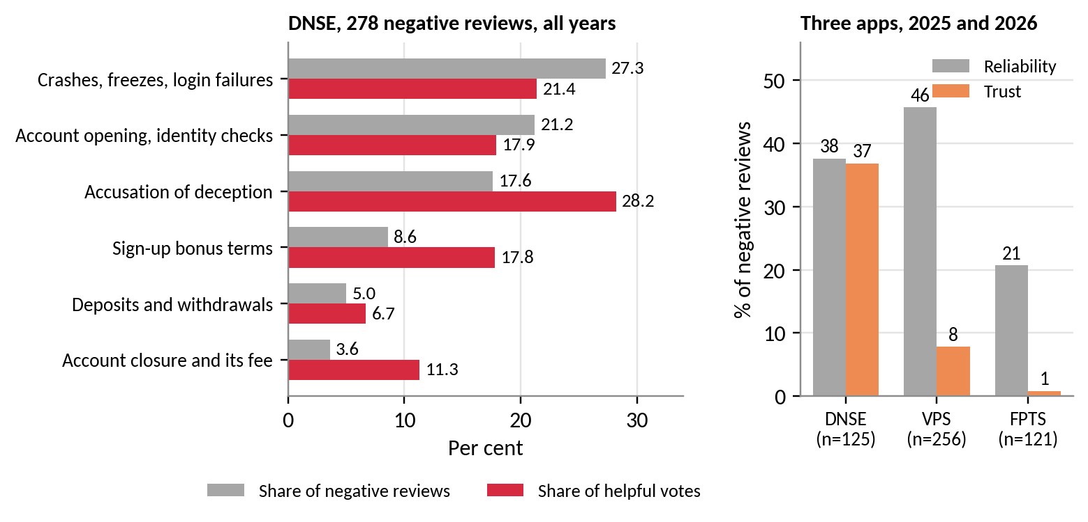
Figure 8. Complaint themes in negative Google Play reviews
Source: Google Play, retrieved 23 September 2026; authors' coding (Appendix D).
Insight: Trust complaints cluster at the first deposit and at withdrawal, the two moments that decide whether an account is funded.

2.7 Finding 6. Saving products exist but reach few customers
The Never-Sleeping Account had 12,100 registered users at the end of 2025, 0.8 per cent of accounts, and Golden Egg had 1,037 active customers in December (DNSE Securities, 2026c). Both products assume that the customer has already decided to deposit. Among Vietnamese adults, 70.5 per cent hold an account, but only 43.1 per cent save at a financial institution (World Bank, 2025). Three segments, the richest 60 per cent, adults in the labour force and adults with secondary education, each contain 15 to 20 million adults with an account and no formal saving (Figure 9). Among investors, 77 per cent find portfolio management difficult and 81 per cent want professional advice (Nhan Dan, 2025; VnEconomy, 2025).
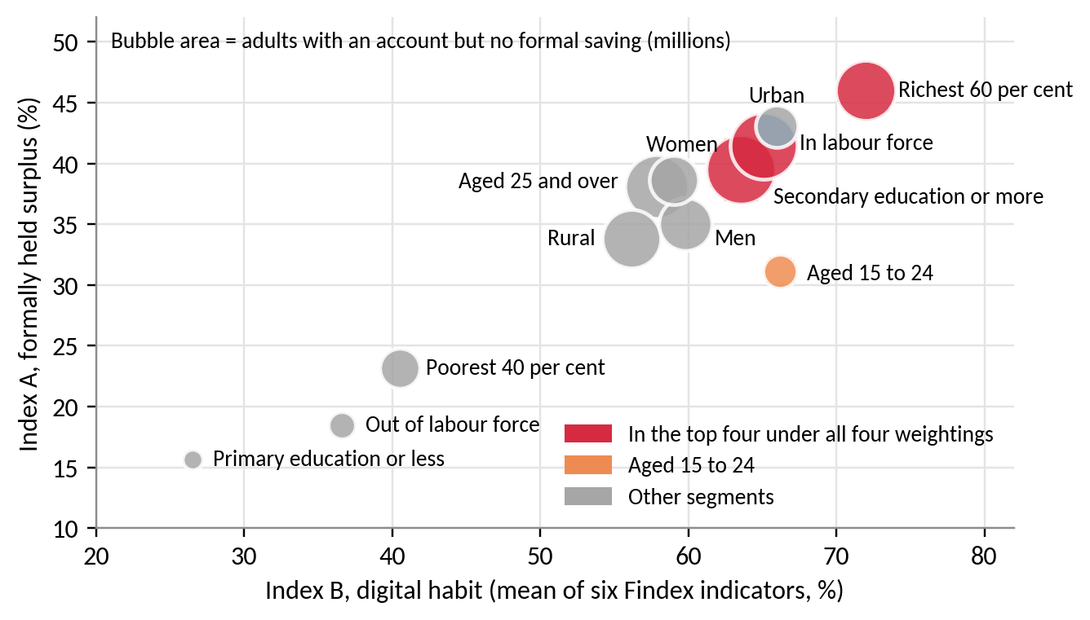
Figure 9. Vietnamese adult segments by digital habit and formally held surplus
Source: World Bank (2025); authors' indices (Appendix E).
Hypothesis: Many salaried adults, probably including many DNSE account holders, have an income, an account and an intention to invest, but they want guidance and keep postponing. The pattern is consistent with procrastination (O'Donoghue & Rabin, 1999).

3. DISCUSSION AND MAIN ANALYSIS

3.1 From symptom to root cause
Zero-fee acquisition makes opening an account costless, so a sign-up carries no commitment to fund it. Figure 10 traces the symptom to three root causes with different strengths of evidence.
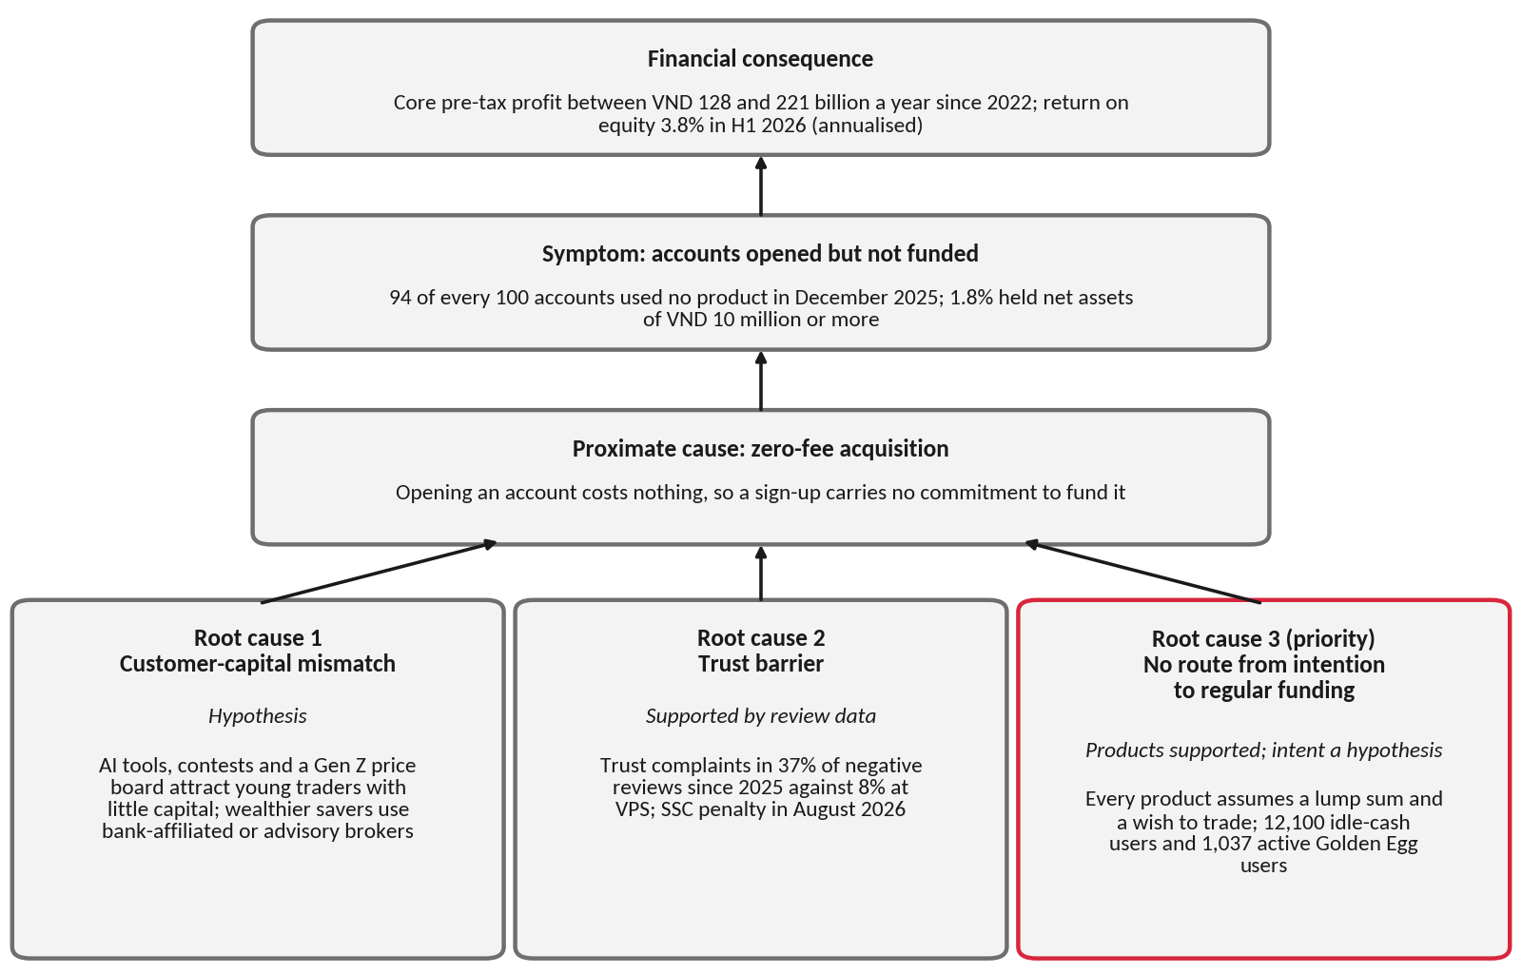
Figure 10. Root-cause tree for unfunded accounts
Source: authors' analysis of Section 2.
The customer-capital mismatch is a hypothesis, supported mainly by a Gen Z share of 31.5 per cent of accounts in mid-2025 (VnExpress, 2025). The trust barrier is supported by review data (Section 3.3). The missing route from intention to regular funding is supported for products and remains a hypothesis for customers (Section 3.4).

3.2 Account growth has not produced balances or profit
Findings 1 to 4 describe a single mechanism. Zero fees attract many small accounts, and each account adds to a platform cost that is largely fixed. Because free trades lose money, profit depends on margin loans, which require customers with assets to pledge and funding that DNSE secures with its own deposits. Between 2021 and 2025, accounts grew 33.8 times and the platform cost proxy 12.5 times, while core pre-tax profit grew 2.7 times (Figure 11).
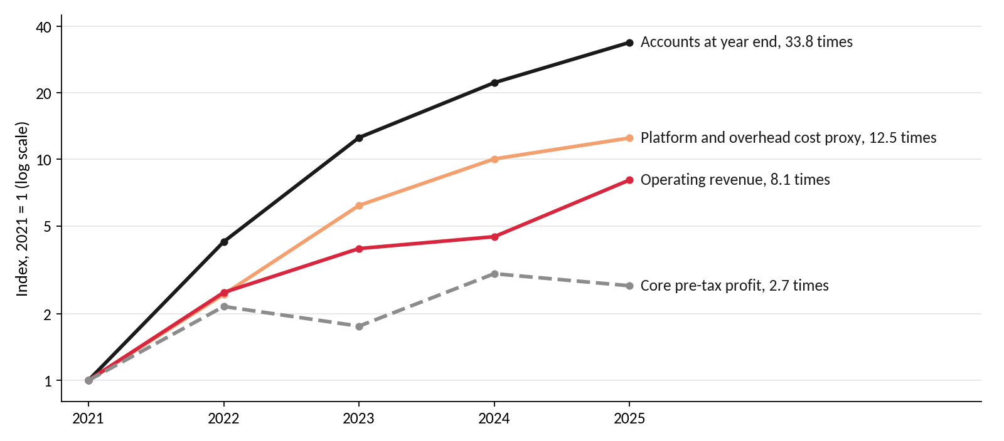
Figure 11. Accounts, revenue, platform cost and core profit, 2021 = 1
Source: Tables B1 and B3; authors' calculations.
The shortfall is large when measured in money. The average Vietnamese securities account held about VND 6.3 million of investor cash in mid-2026, against VND 1.2 million at DNSE. At the industry average, DNSE would hold about VND 10.6 trillion, 5.4 times its actual balance (Table C1). Each account that stays empty therefore adds cost without adding the balances on which DNSE earns.

3.3 Trust fails at the point of deposit
The mean rating of substantive DNSE reviews fell from 4.15 in 2024 to 2.38 in 2025, and the fall holds under every cleaning rule (Table A4). That year DNSE opened 518,514 accounts. The three most-endorsed complaints date from May and June 2025, and all three concern reward conditions or the closure fee (Table D3). VPS draws more reliability complaints than DNSE but lends five times more per account, which suggests that customers tolerate technical faults more readily than terms they consider unfair. The pattern is consistent with conditional rewards that raised sign-ups but weakened trust at the first deposit, so a solution should avoid them.

3.4 Intention without a route to investment
About 22.1 million Vietnamese adults hold an account but do not save formally (Table E1). Among the richest 60 per cent, 85.5 per cent hold an account and 49.5 per cent receive wages into one, yet only 53.8 per cent save at a financial institution. For these adults the salary already arrives in an account, so the missing step is a regular transfer from that account into an investment. When each deposit is a fresh decision, people who intend to save tend to postpone it (O'Donoghue & Rabin, 1999).
Evidence from other markets shows that product design can close this gap. Automatic enrolment raised pension-plan participation from 37 to 86 per cent (Madrian & Shea, 2001), and pre-committed saving raised saving rates from 3.5 to 13.6 per cent (Thaler & Benartzi, 2004). A commitment savings account raised balances by 81 percentage points against a control group after one year (Ashraf et al., 2006). Whether DNSE's dormant customers are salaried savers of this kind remains a hypothesis for Round 3.

3.5 Alternative explanations
Four other explanations were tested (Table F2). The market cycle does not explain the gap, since assets per account fell 9.5 per cent in 2025 while the VN-Index rose 41 per cent (Thanh Nien, 2025). A shortage of lending capital is also unlikely, as loans stood at 116 per cent of equity against a ceiling of 200 per cent. Dormancy common to all brokers does not fit either, because VPS, VPBankS and TCBS lend 5 to 12 times more per account. Only a deliberate plan to earn from young customers later cannot be rejected without cohort data.

3.6 Core problem and design conditions
Problem statement: Most DNSE accounts are never funded. At the end of 2025, 98 per cent held less than VND 10 million, so fewer than 2 in 100 carried the platform's cost. No DNSE product turns an intention to invest into regular deposits, and trust complaints deter the first deposit.
The problem is urgent. Open banking will let every competitor link salary accounts from March 2027, and DNSE had delivered 20 per cent of its 2026 profit target by mid-year (Vietstock, 2026a). Four conditions follow for any solution. It should bring money in without a large one-off decision, earn from balances without new pledged borrowing, rebuild trust through small and reversible steps without conditional rewards, and fit DNSE's licences.

4. RECOMMENDATIONS

4.1 Payday Portfolio
We recommend Payday Portfolio, a goal-based plan that moves part of each salary into a diversified portfolio on payday. It targets dormant account holders who receive a salary and extends to new salaried customers once a pilot confirms demand (Table E3). Each component meets a condition from Section 3.6 (Figure 12). The payday transfer brings money in without a monthly decision, advice through Ensa supplies guidance, and small, reversible contributions let customers test DNSE before they commit more. Because revenue comes from fees on funds and bonds, balances can grow without new pledged borrowing.
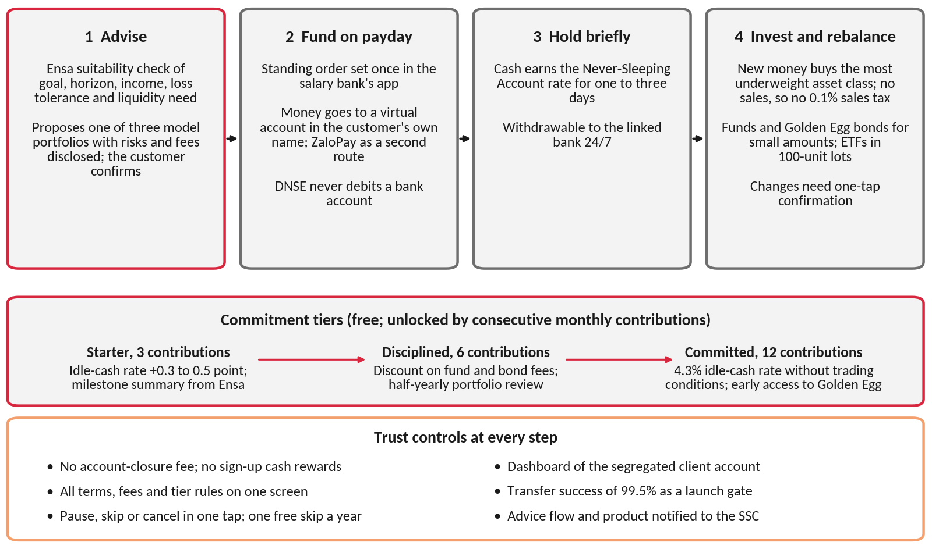
Figure 12. How Payday Portfolio works
Source: authors' design.

4.2 How Payday Portfolio works
Payday Portfolio runs inside DNSE's licensed advisory service, Investment Ideas (DNSE Securities, 2026d). As Circular 121/2020/TT-BTC requires, Ensa first records the customer's goal, time horizon, income and tolerance for losses (Ministry of Finance, 2020, Article 24). It then proposes a Conservative, Balanced or Growth model portfolio built from bond funds, Golden Egg bonds, equity funds and VN30 exchange-traded funds, and the customer confirms the choice. Single stocks are excluded.
After set-up, contributions arrive without further decisions. The customer chooses a monthly amount from VND 500,000 and creates a standing order once in the salary bank's app. The money goes to a virtual account number in the customer's own name at DNSE's partner bank, and is credited automatically, which reduces the transfer errors behind complaints about uncredited deposits (Table D1). ZaloPay, a DNSE partner since 2023, offers a second route (Thanh Nien, 2023), and direct bank connections can follow from March 2027.
Arriving cash earns the Never-Sleeping Account rate for the one to three days before it is invested and remains withdrawable at any time. Ensa then directs each contribution to the asset class furthest below its target weight. Rebalancing with new money avoids sales, so the customer pays no 0.1 per cent tax on sales and no extra trading fees. Small amounts go to open-ended funds and to Golden Egg bonds from VND 1 million, while exchange-traded fund purchases wait until the balance covers a 100-unit lot. The plan executes only the amounts and products the customer has chosen, and any change of allocation needs a one-tap confirmation, because a securities company may not invest on a client's behalf (Ministry of Finance, 2020, Article 4).
Commitment tiers reward persistence without a membership fee. Customers unlock three tiers through consecutive monthly contributions, so every reward depends on money that stays. The Starter tier, after three contributions, covers the 90-day point at which customers test deposits and withdrawals, and it adds 0.3 to 0.5 percentage points to the idle-cash rate. The Disciplined tier, after six contributions, adds a discount on fund and bond fees and a half-yearly portfolio review. The Committed tier, after twelve contributions, pays the top idle-cash rate of 4.3 per cent without the current balance and trading conditions and gives early access to new Golden Egg issues. A visible streak makes the next contribution the default, and the prospect of losing a tier weighs more than an equal gain (Kahneman & Tversky, 1979). Each customer may skip one month a year without losing a tier, which protects savers whose income varies. Rewards exclude margin, since leverage conflicts with a saver's goal. Success is measured by balances, because six contributions of VND 1 million still leave a saver below VND 10 million (Figure 13).
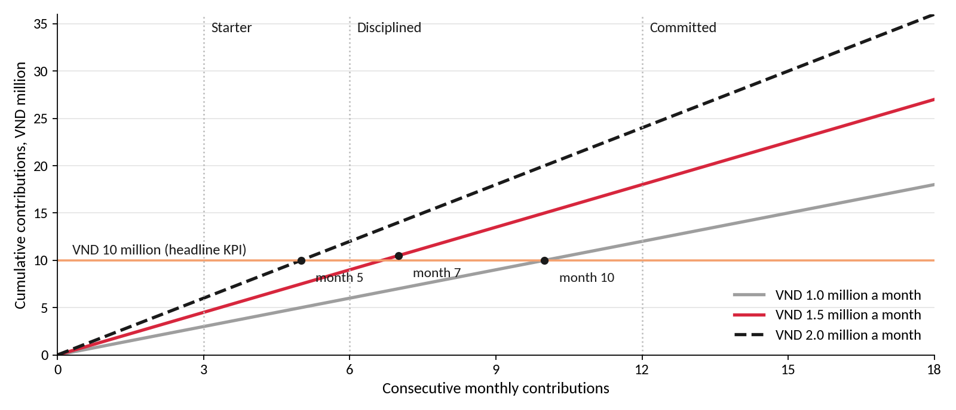
Figure 13. Contributions needed to reach VND 10 million, before investment returns
Source: authors' calculations.
Trust controls cover each step at which complaints arise. DNSE removes the account-closure fee and replaces conditional sign-up rewards with tier rewards. All terms, fees and tier rules appear on one screen, and customers can pause, skip or cancel in one tap. A dashboard shows the segregated client account that holds the customer's cash, and transfer success of 99.5 per cent is a condition for launch.

4.3 How Payday Portfolio resolves the core problem
The cost is modest. Tier interest would cost at most VND 5.6 billion a year for 150,000 savers, while a VND 100,000 reward on every account opened in 2025 would have cost VND 51.9 billion (Appendix F1).
Table 1. The problem statement and the Payday Portfolio response
Part of the problem | Payday Portfolio response | Evidence
98 per cent of accounts hold less than VND 10 million | A payday standing order brings money in without a monthly decision | Automatic enrolment raised participation from 37 to 86 per cent (Madrian & Shea, 2001)
No product turns intention into regular deposits | Goal-based model portfolios through Ensa; rebalancing with new money | 77 per cent of investors find portfolio management difficult (Section 2.7)
Trust complaints deter the first deposit | Small, reversible transfers; no closure fee; one-screen terms; segregated-cash dashboard | Trust complaints in 37 per cent of negative reviews, against 8 per cent at VPS (Section 2.6)
Fewer than 2 in 100 accounts carry the platform's cost | Balances build in accounts already acquired; fee income needs no pledged borrowing | Base case lifts accounts above VND 10 million to about 177,000 and cuts platform cost per funded account from VND 7.3 million to 1.1 million (Table F5)
Source: Sections 2 and 3; Appendix F; authors' design.

4.4 Extending DNSE's technology ecosystem
DNSE's technology rests on four platforms, namely Entrade X for zero-fee share trading, Future X for derivatives, Margin Deal for deal-by-deal margin loans and the Ensa assistant. It also runs Lightspeed API for algorithmic trading, two saving products and a distribution link with ZaloPay (DNSE Securities, 2026e). Most of this technology serves active traders, while the zero-fee policy has attracted young customers with small balances. As a result, the platform behaves as a fixed cost carried by few funded accounts (Finding 4). Payday Portfolio gives these components a shared purpose, which is to bring in and keep customer balances (Figure 14). Three upgrades extend this role.
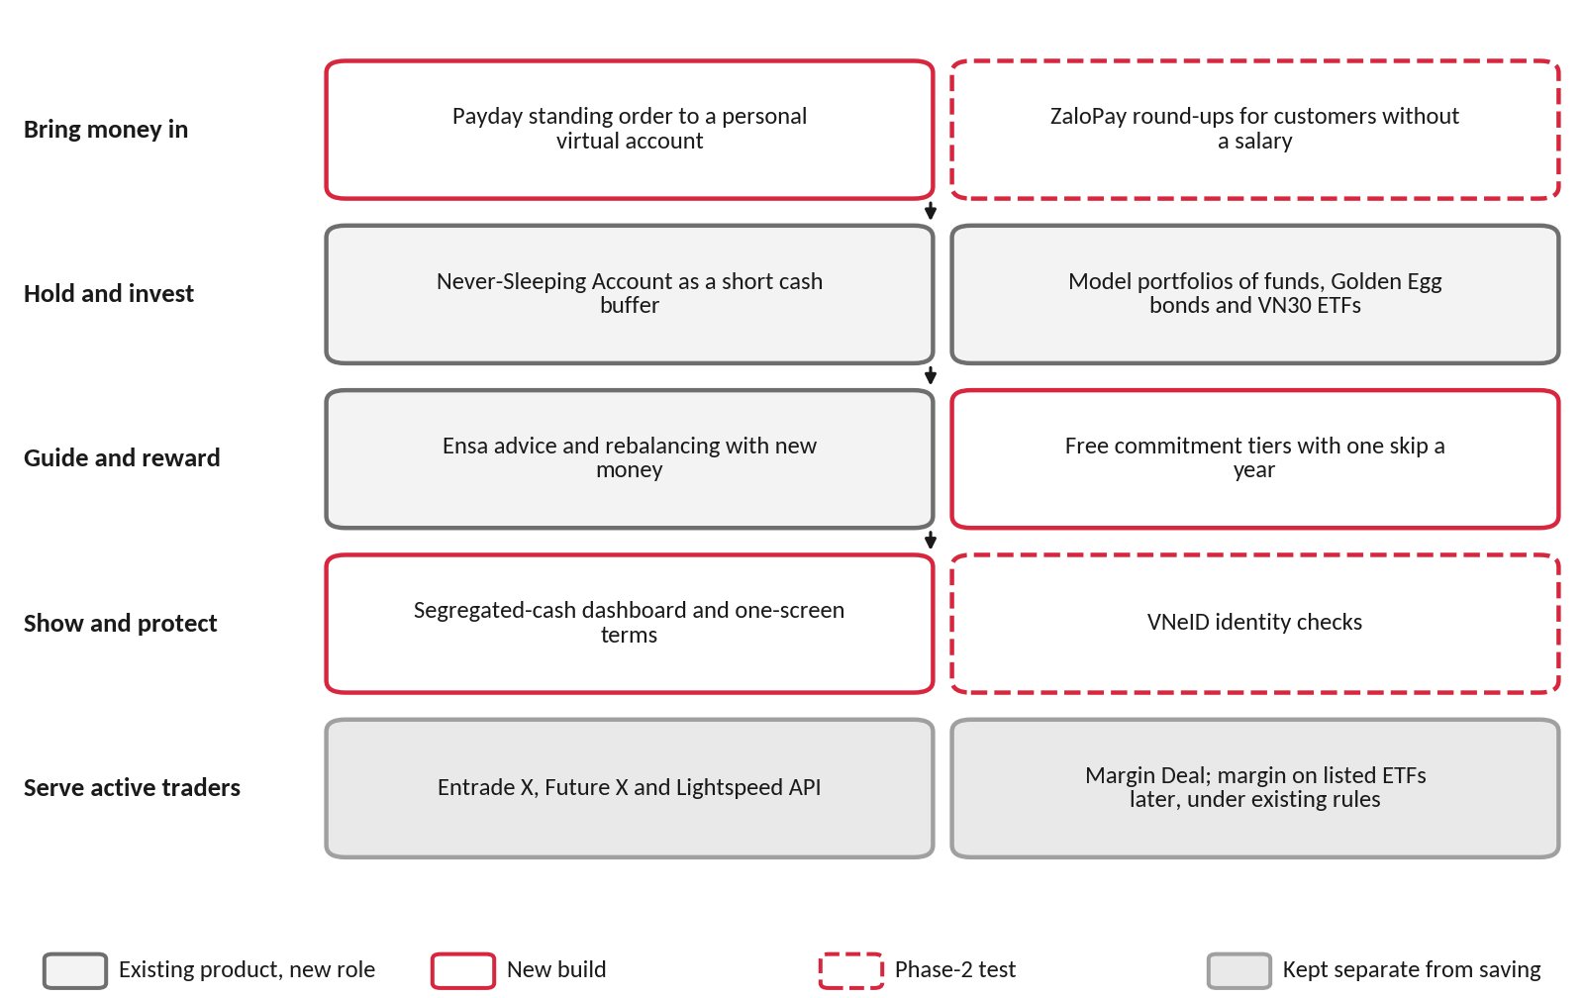
Figure 14. DNSE's technology ecosystem organised around customer balances
Source: authors' design; Appendix G.
First, ZaloPay round-ups can serve as an entry route for customers without a regular salary. Each payment is rounded up to the nearest VND 10,000, and the difference collects in the Never-Sleeping Account until it reaches VND 100,000, when it buys fund units in the customer's model portfolio. Round-ups remove the barrier of a first lump-sum deposit, but the amounts are small. At an assumed 30 payments a month and an average round-up of VND 5,000, a customer would add about VND 150,000 a month, so round-ups complement the payday transfer and should be tested in phase 2.
Second, the Smart Vault idea can be offered in a compliant form. Rule-based strategies, such as a high-dividend or VN30 momentum strategy, can become additional model portfolios under the advisory licence, with each order confirmed by the customer. Automatic execution for an asset-based fee raises a licensing issue, because portfolio management is not among the four businesses permitted to securities companies (National Assembly, 2019, Article 72). A fully managed version should therefore come from a licensed fund manager whose funds DNSE distributes.
Third, a transparency layer turns the trust controls into evidence that customers can check. The segregated-cash dashboard shows where each customer's cash is held, the interest earned and the status of every withdrawal. Identity checks through the national VNeID application should also be tested, since account opening and identity checks appear in 21 per cent of negative reviews (Table D1).
A credit line secured on savings is not recommended. Circular 121/2020/TT-BTC restricts lending by securities companies to margin loans and a few defined purposes (Ministry of Finance, 2020, Article 27), open-ended fund units are not listed securities, and the 2026 fine concerned unreported advance services. Margin on listed exchange-traded funds can follow later under existing rules (Appendix G).

5. CONCLUSION
DNSE acquires customers at scale, but fewer than 2 in 100 accounts carry its platform and borrowing costs. Payday Portfolio acts on the cause DNSE controls most by combining licensed advice, payday automation, free commitment tiers and trust controls. The ecosystem upgrades direct DNSE's existing technology towards customer balances. Appendix F sets out the scenarios, KPIs and pilot tests for Round 3.

APPENDICES

Appendix A. Data preparation and quality
Table A1. Evidence base and preparation
Dataset | Coverage | Main preparation step | Remaining limitation
DNSE filed statements | 395 line items, first quarter of 2018 to second quarter of 2026 | Pulled line by line from Vietcap IQ; reconciled to the half-year statements reviewed by KPMG | Template line 24 mixes provisions with borrowing cost
DNSE annual report 2025 | Accounts, active customers, net-asset bands, product users | Figures read from the report and dated | Company-defined measures; active means at least one product used in the month
Peer statements and indicators | Four peers; accounts, lending, funding, profit | Same cost-of-funds method as for DNSE; each figure dated | Account counts differ in date and definition
Exchange and industry data | HOSE and HNX shares; industry lending, investor cash and profit | Each share kept within its own exchange; broadest industry total used | Press tallies differ slightly in coverage
App store reviews | 867 Google Play and 332 App Store reviews of DNSE; 2,100 of VPS and FPTS | Spam and duplicates removed; one-word reviews flagged; themes coded | Self-selected sample; levels overstate dissatisfaction
World Bank Global Findex 2024 | 51 indicators across 13 segments for Vietnam | Two indices built; segment weights recovered from the survey | About 1,000 interviews; one dimension at a time
Macro and banking data | Growth, inflation, credit, deposit rates, deposits | Dated at source; projections labelled | Some series reported only through the press
Source: compiled by the authors; access dates 20 to 25 September 2026.
A1. Reconciliation. Where press reports and the filings differ, the reviewed filings are used (Table A2). The half-year statements reviewed by KPMG raise administrative expenses by VND 1.5 billion against the quarterly statement of 20 July 2026. The press figure of VND 1,467 billion for 2025 revenue includes financial income, and the filings report VND 1,457.9 billion of operating revenue.
Table A2. Press figures reconciled with the filings, VND billion
Item | Press or earlier data pack | Filings used | Reason for the difference
Pre-tax profit, Q2 2026 | 98.9 | 97.4 | Reviewed half year less the first quarter
Pre-tax profit, H1 2026 | 113.1 | 111.6 | Reviewed statements of 14 August 2026
Operating revenue, 2025 | 1,467.0 | 1,457.9 | Press total includes financial income
Revenue growth, 2025 | 77% | 80.6% | Follows from the line above
Proprietary provisions, Q1 2026 | plus 405% | not used | No line of the filings reproduces the figure
Source: DNSE filings via Vietcap Securities (2026); DNSE Securities (2026a); press reports cited in Section 2.
A2. Transformations. The cost of funds equals interest expense plus template line 24, less the rise in the balance-sheet allowance for loan losses, multiplied by four and divided by average borrowings and bonds. The net interest margin deducts this cost from interest on loans, deposits and bonds held to maturity, over average interest-earning assets. Core pre-tax profit excludes the net result on financial assets at fair value through profit or loss. Per-account values divide a balance or flow by accounts at the same date. The same formulas are applied to peers.
A3. Concentration bound. At the end of 2025 DNSE reported 1,512,920 accounts, of which 27,100 held net assets of VND 10 million or more, and customer assets of VND 53,471 billion. The other 1,485,820 accounts each hold less than VND 10 million net, or at most VND 14,858 billion together. Their gross assets can exceed net assets only by what they borrow, and total lending was VND 5,832 billion. They can therefore hold at most VND 20,690 billion, so accounts with VND 10 million or more hold at least VND 32,781 billion, or 61 per cent of customer assets. The bound is conservative because it assigns every loan to the smaller accounts.
A4. Denominators, missing values and outliers. HOSE and HNX report market share within their own exchange, so shares are never compared across exchanges. Industry lending (VND 453.8 trillion including advances) and investor cash (VND 86.6 trillion) use the broader published totals, and narrower totals raise DNSE's shares by about 0.1 point. The industry cash total for the fourth quarter of 2025 and DNSE's derivatives share for the second and third quarters of 2024 were not published and are left missing. DNSE's investor cash fell to VND 429 billion in the first quarter of 2025 and recovered the next quarter. The value appears in the filings and probably reflects settlement timing. It stays in the series and is excluded from trend statements.
A5. Platform cost proxy. DNSE does not report technology spending. The proxy sums staff costs and outsourced services from the note on general and administrative expenses and total depreciation and amortisation from the cash flow statement. It may include non-technology overheads and exclude technology staff costs booked under brokerage expenses, so it is used for trend and order of magnitude only.
Table A3. Review cleaning log
Stage | DNSE, Play | VPS, Play | FPTS, Play | DNSE, iOS | VPS, iOS | FPTS, iOS
Reviews retrieved | 867 | 1,200 | 177 | 332 | 518 | 205
Loan advertising removed | 127 | 23 | 0 | 0 | 0 | 0
Referral farming removed | 70 | 3 | 0 | 73 | 6 | 0
Duplicates removed | 0 | 3 | 0 | 0 | 0 | 0
Reviews retained | 670 | 1,171 | 177 | 259 | 512 | 205
Mean rating before cleaning | 3.29 | 2.60 | 2.18 | 3.37 | 1.57 | 2.31
Mean rating after cleaning | 3.22 | 2.58 | 2.18 | 2.94 | 1.53 | 2.31
Source: Google Play (23 September 2026) and Apple App Store (24 September 2026); authors' cleaning code. Text was normalised (Unicode compatibility composition, diacritics removed, lower case) before two rules flagged loan advertising and referral farming. The referral rule fires only where a referral phrase sits next to a code or reward amount and passes 37 test cases. Copy-and-paste duplicates of 20 characters or more were removed, and identical short reviews by different people were kept. VPS is its 1,200 most recent Google Play reviews, from 27 March 2023.
Cleaning changed the conclusions. In 2022 and 2023, 46 and 54 per cent of DNSE's Google Play reviews were spam, and the removed material was rated higher than the genuine reviews (3.53 against 3.22), so cleaning lowers DNSE's rating. Table A4 tests the rule that flags generic reviews.
Table A4. Sensitivity of the generic-review rule, DNSE Google Play
Rule for a generic review | Generic share, 2024 | Generic share, 2025 | Substantive mean, 2024 | Substantive mean, 2025
One word (rule used) | 33.7% | 12.0% | 4.15 | 2.38
Up to two words | 50.3% | 17.7% | 4.00 | 2.22
Up to four words | 62.7% | 25.9% | 3.74 | 2.01
Source: authors' cleaning code. The fall in substantive ratings from 2024 to 2025 holds under every rule.

Appendix B. DNSE financial data
Table B1. Income statement summary, VND billion
Item | 2021 | 2022 | 2023 | 2024 | 2025 | H1 2026
Operating revenue | 180.7 | 452.1 | 714.5 | 807.4 | 1,457.9 | 848.2
Interest on margin loans and advances | 42.7 | 223.1 | 286.2 | 360.5 | 555.8 | 336.1
Interest on deposits and bonds held to maturity | 20.1 | 112.9 | 196.0 | 245.0 | 303.9 | 193.4
Brokerage revenue | 90.0 | 84.8 | 67.6 | 144.8 | 404.0 | 222.1
Direct brokerage cost | 51.5 | 74.4 | 111.1 | 174.8 | 464.9 | 266.5
Interest expense plus line 24 | 23.9 | 172.2 | 233.6 | 210.6 | 429.8 | 324.1
Administrative expenses | 14.8 | 37.1 | 94.3 | 151.9 | 181.4 | 95.4
Pre-tax profit | 68.2 | 95.0 | 285.6 | 227.5 | 340.2 | 111.6
Net proprietary result | (4.4) | (61.3) | 158.0 | 6.8 | 146.2 | 33.9
Core pre-tax profit | 72.5 | 156.3 | 127.6 | 220.7 | 194.0 | 77.7
Source: DNSE filed statements via Vietcap Securities (2026); H1 2026 from the half-year statements reviewed by KPMG; authors' calculations. Core pre-tax profit excludes the net result on financial assets at fair value through profit or loss. Negative values are in parentheses.
Table B2. Balance sheet and main ratios
Item | 2021 | 2022 | 2023 | 2024 | 2025 | Jun 2026
Margin loans and advances, VND bn | 1,192 | 2,280 | 2,483 | 3,882 | 5,832 | 6,303
Deposits and bonds held to maturity, VND bn | 883 | 2,824 | 3,495 | 5,103 | 6,266 | 5,714
Total assets, VND bn | 2,315 | 6,409 | 7,446 | 10,637 | 15,139 | 15,208
Borrowings and bonds, VND bn | 1,224 | 2,735 | 3,643 | 6,494 | 10,600 | 9,446
Owners' equity, VND bn | 1,059 | 3,136 | 3,305 | 4,030 | 4,302 | 5,440
Investor cash (off balance sheet), VND bn | 435 | 251 | 790 | 1,340 | 2,903 | 1,961
Pre-tax margin, % | 37.7 | 21.0 | 40.0 | 28.2 | 23.3 | 13.2
Brokerage revenue as % of direct cost | 174.9 | 114.0 | 60.9 | 82.8 | 86.9 | 83.3
Return on equity, % | 8.9 | 3.7 | 7.1 | 5.0 | 6.5 | 3.8
Loans as % of equity (ceiling 200) | 112.6 | 72.7 | 75.1 | 96.3 | 135.6 | 115.9
Estimated cost of funds, % | 6.5 | 6.8 | 7.3 | 4.1 | 5.1 | 6.3
Net interest margin, % | 6.2 | 5.4 | 4.8 | 5.0 | 4.2 | 3.5
Source: as Table B1. Return on equity, cost of funds and net interest margin in the last column cover the first half of 2026, annualised. Section 2.4 and Table C2 quote the second quarter alone, when the cost of funds was 6.5 per cent.
Table B3. Platform and overhead cost proxy, VND billion
Item | 2021 | 2022 | 2023 | 2024 | 2025
Staff costs (administration) | 8.6 | 12.1 | 41.2 | 80.0 | 99.4
Outsourced services | 4.8 | 21.5 | 40.4 | 52.8 | 62.7
Depreciation and amortisation (all) | 2.4 | 5.0 | 16.2 | 25.9 | 35.4
Platform cost proxy | 15.8 | 38.7 | 97.8 | 158.8 | 197.5
Software and leased equipment at cost | 20.0 | 44.7 | 95.7 | 129.1 | 168.5
Accounts at year end | 44,727 | 189,845 | 561,279 | 994,811 | 1,512,920
Active customers, December | n.a. | n.a. | n.a. | about 41,900 | 85,739
Proxy per active customer, VND million | n.a. | n.a. | n.a. | 3.79 | 2.30
Source: DNSE filed statements (notes on administrative expenses; cash flow statement; notes on intangible and finance-lease assets); DNSE Securities (2026c); authors' calculations.
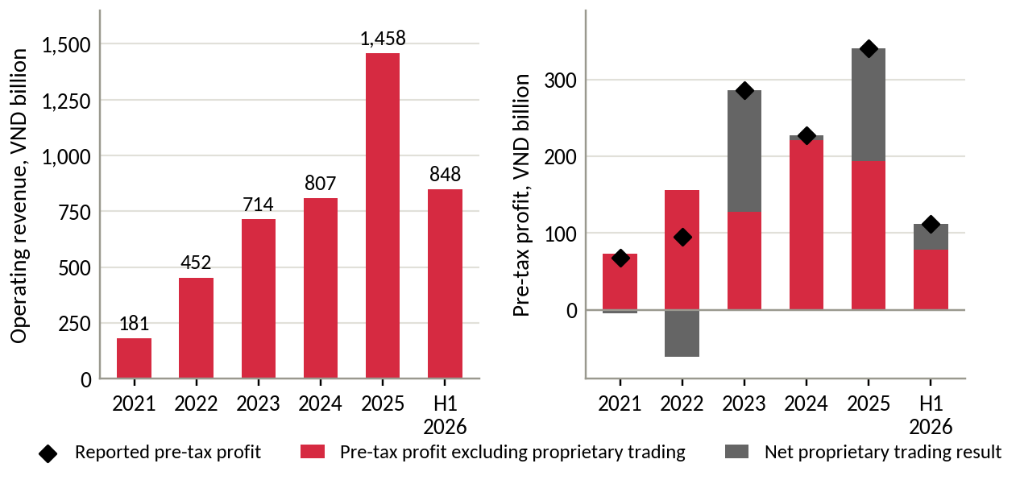
Figure B1. Operating revenue and pre-tax profit split into core business and proprietary trading
Source: DNSE filings; authors' calculations.
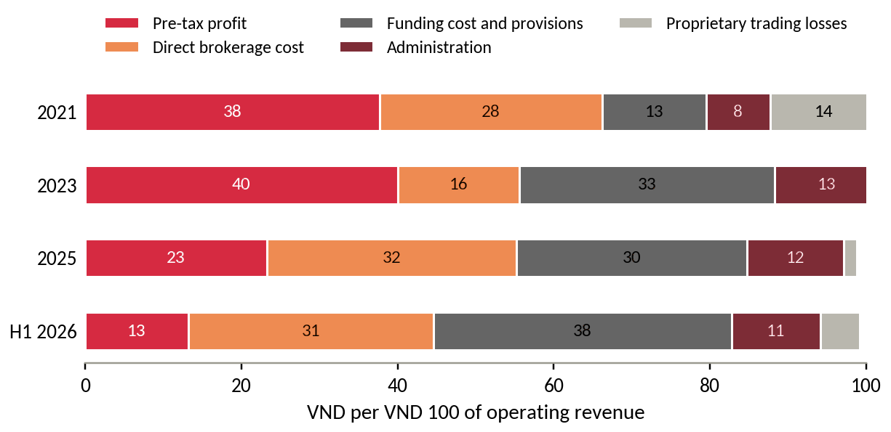
Figure B2. Where each VND 100 of operating revenue goes
Source: DNSE filings; authors' calculations.
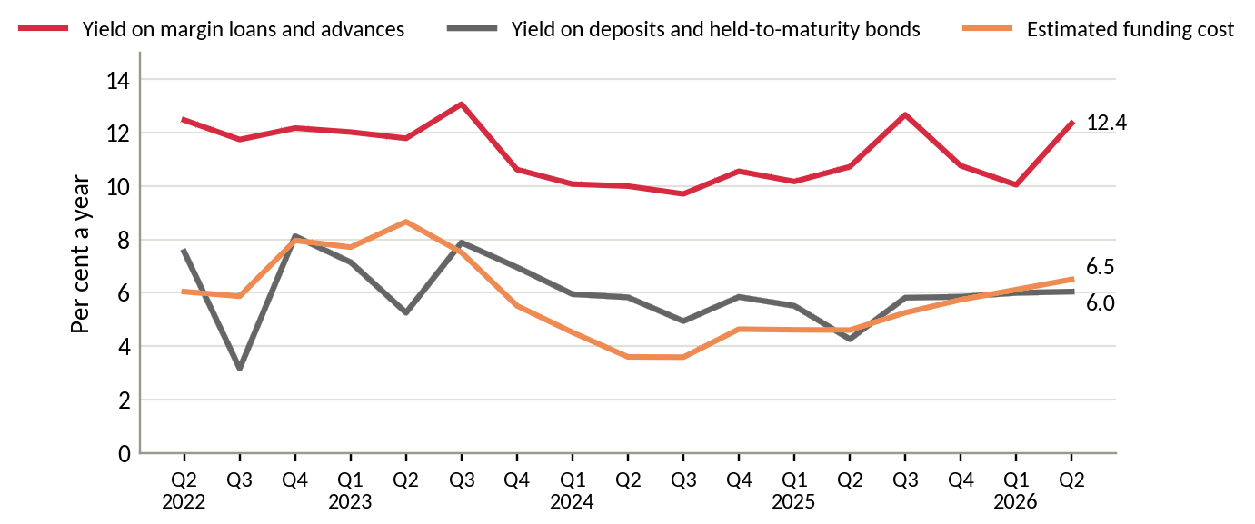
Figure B3. Yield on margin loans and on deposits and bonds held to maturity, against the estimated cost of funds
Source: DNSE filings; authors' calculations.
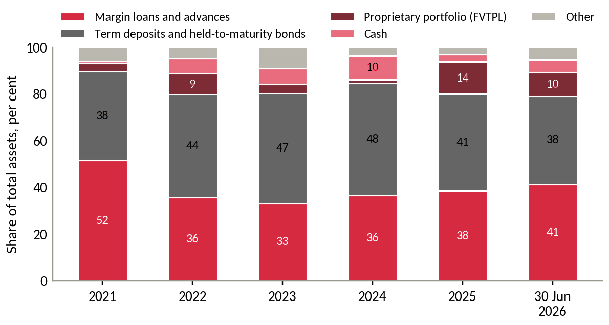
Figure B4. Composition of DNSE total assets
Source: DNSE filings.

Appendix C. Market and peer data
Table C1. DNSE's position on eight measures
Measure | DNSE | Market total | DNSE share, % | Ratio to account share
Securities accounts, mid-2026 | 1.70 million | 13.85 million | 12.27 | 1.00
New accounts, 2025 | 518,514 | 2,573,945 | 20.14 | 1.64
Derivatives brokerage, Q2 2026 | 2nd place | HNX | 25.38 | 2.07
Listed-share brokerage on HNX, Q2 2026 | 8th place | HNX | 2.88 | 0.23
Cash equity trading, Q2 2026 (estimate) | VND 62.9 trillion | all exchanges | 2.1 to 2.6 | 0.17 to 0.21
Investor cash at brokers, 30 June 2026 | VND 1,961 billion | VND 86.6 trillion | 2.26 | 0.18
Margin lending, 30 June 2026 | VND 6,303 billion | VND 453.8 trillion | 1.39 | 0.11
Pre-tax profit, Q2 2026 | VND 97.4 billion | VND 15,200 billion | 0.64 | 0.05
Source: VnExpress (2026a); DNSE Securities (2026c); Vietstock (2026c); CafeF (2026); VnEconomy (2026); Hanoi Stock Exchange (2026); DNSE filings; authors' calculations. The trading estimate divides the value of shares DNSE's customers traded by twice the value traded on HOSE plus 7 per cent for HNX and UPCoM.
Table C2. DNSE against named peers
Indicator | DNSE | VPBankS | TCBS | VPS
Customer accounts, million | 1.70 | 1.30 | 1.20 | 1.55
Margin lending, 30 June 2026, VND bn | 6,303 | 38,200 | 51,500 | 31,300
Lending per account, VND million | 3.7 | 29.4 | 42.9 | 20.2
Pre-tax profit per account, Q2 2026, VND thousand | 57 | 1,661 | 1,748 | 891
Deposits and bonds held to maturity, % of assets | 37.6 | 6.5 | 4.6 | 4.3
Estimated cost of funds, Q2 2026, % | 6.5 | 6.8 | 7.8 | 5.1
Parent bank | none | VPBank | Techcombank | none
Source: filed statements via Vietcap Securities (2026); company releases for account counts (VPBankS May 2026; TCBS end-2025; VPS September 2025); Vietstock (2026c); authors' calculations. Per-account values are averages that large clients raise at every firm. SSI, with no parent bank, holds 8.6 per cent of assets in deposits and bonds and has a cost of funds of 6.1 per cent.
Table C3. Competitive landscape of Vietnamese retail brokerage and savings
Model | Examples | How it earns | Strength | Gap for salaried savers
Bank-affiliated brokers | TCBS, VPBankS, MBS | Margin lending, bond distribution | Cheap funding, capital, parent-bank customers and trust | Serve mainly their parents' customers; TCBS iPower pays interest only above VND 5 million
Independent full-service brokers | SSI, HSC, Vietcap | Margin, institutional brokerage, advisory | Research, brand, human brokers | Costly to serve small savers
Retail trading platforms | VPS | Retail and derivatives brokerage, margin | Largest retail share | Trading-first; no link from a salary
Zero-fee digital brokers | DNSE, Pinetree | Margin, derivatives | Low cost, fast technology, young customers | Small balances; no regular-saving product
Banks' automatic-earning accounts | Large commercial banks | Deposit spread | Salary accounts, trust | Little choice beyond deposits
Source: company statements and product pages; TCBS (2026); Vietstock (2026b); authors' assessment.
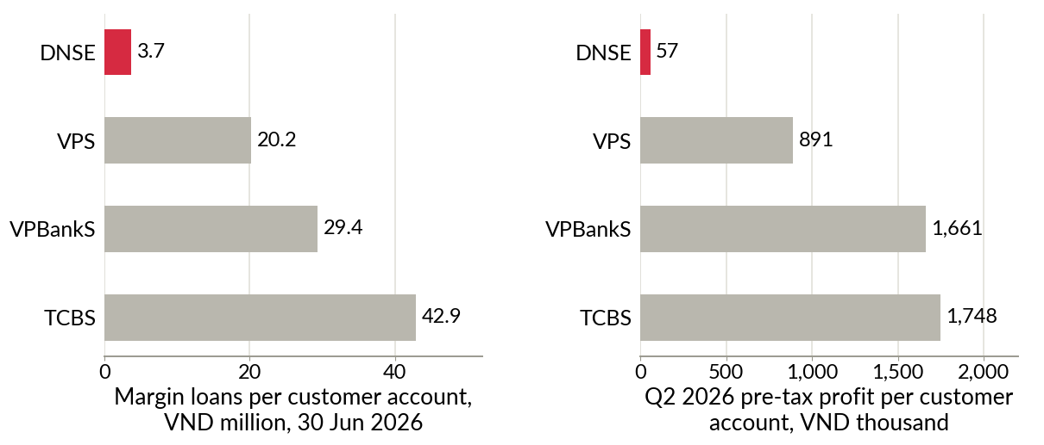
Figure C1. Lending and profit per customer account, DNSE against VPS, VPBankS and TCBS
Source: as Table C2.

Appendix D. Customer review analysis
Table D1. Themes in DNSE's negative Google Play reviews
Theme | Negative reviews | Share of negative reviews, % | Share of helpful votes, %
Crashes, freezes, login failures, slow orders | 76 | 27.3 | 21.4
Account opening, identity checks, one-time passwords | 59 | 21.2 | 17.9
Explicit accusation of deception | 49 | 17.6 | 28.2
Sign-up bonus terms, rewards not received | 24 | 8.6 | 17.8
Deposits not credited, withdrawal delays | 14 | 5.0 | 6.7
Cannot close the account, closure fee | 10 | 3.6 | 11.3
Any trust theme (deception, bonus terms, closure) | 67 | 24.1 | 42.9
Any product theme (stability, onboarding) | 118 | 42.4 | 34.1
Idle-cash product (Never-Sleeping Account), all reviews | 3 mentions, all positive
Source: Google Play, retrieved 23 September 2026; authors' coding. 278 one- and two-star reviews carrying 1,794 helpful votes. Themes are not exclusive.
Table D2. Reliability and trust complaints at three brokers, January 2025 to September 2026
Application | Negative reviews | Reliability, % of reviews | Reliability, % of votes | Trust, % of reviews | Trust, % of votes | App Store mean, 2025 to 2026
DNSE Entrade X | 125 | 37.6 | 30.2 | 36.8 | 50.4 | 2.25
VPS SmartOne | 256 | 45.7 | 45.1 | 7.8 | 7.3 | 1.47
FPTS EzTrade | 121 | 20.7 | 17.7 | 0.8 | 1.8 | 2.31
Source: Google Play (retrieved 23 September 2026) and Apple App Store (retrieved 24 September 2026); authors' cleaning and coding. Reliability covers crashes, freezes, login failures, slow orders and account opening. Trust covers accusations of deception, sign-up bonus terms and account closure.
Table D3. Selected DNSE reviews, translated from Vietnamese
Date | Stars | Helpful votes | Review
9 Jun 2025 | 1 | 58 | "Everyone, be careful, it is a scam. You do not receive the 100k. To delete your account you have to pay it 100k."
24 May 2025 | 1 | 54 | "I have been trapped ... you cannot cancel the registration ... after approval you have to go to the head office to delete the account."
28 Jun 2025 | 1 | 50 | "Deceptive and false. There is no 100k straight away. You have to deposit at least 2 million to get it."
2 Jun 2025 | 2 | 18 | "When I deposit outside trading hours, the money leaves my bank account but the securities account does not receive it."
15 May 2026 | 5 | 13 | "... The idle account is the best. Watching the interest rise in real time is satisfying, and money earns interest automatically once it is deposited."
Source: Google Play; translated by the authors.
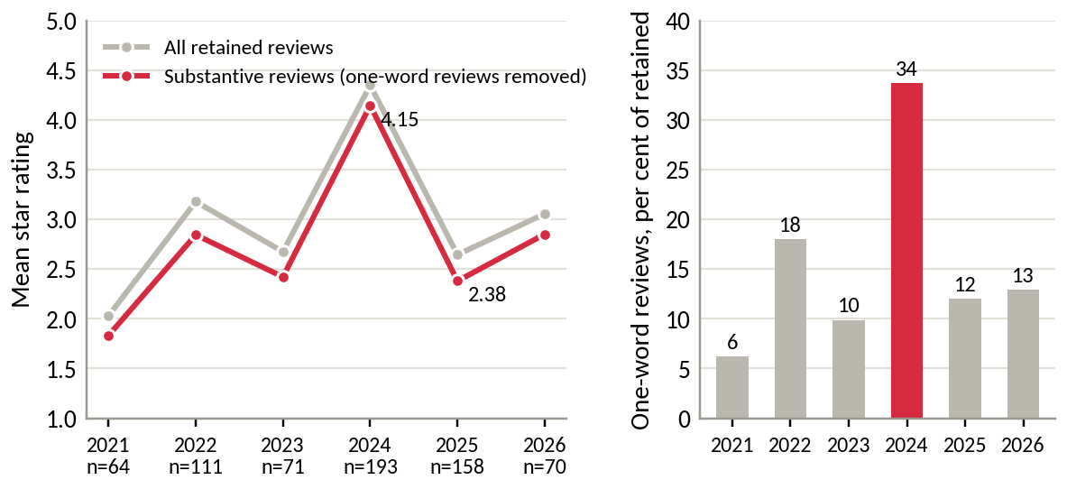
Figure D1. Mean rating of DNSE reviews by year, and the share of one-word reviews
Source: Google Play; authors' cleaning.
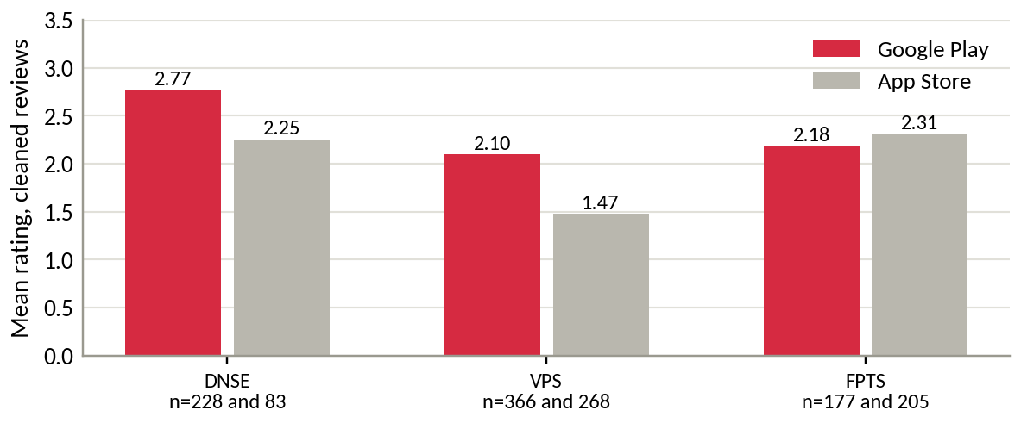
Figure D2. Mean rating of cleaned reviews on Google Play and the App Store, 2025 and 2026
Source: Google Play and Apple App Store; authors' cleaning.
Regulatory record. Decision 461/QD-XPHC of the State Securities Inspectorate, issued on 17 August 2026, fined DNSE VND 802.5 million. The largest item, VND 275 million, concerned three services supporting derivatives brokerage (advances against open-position gains, out-of-hours advances on margin withdrawals and advances of margin deposits), offered from January 2024 to June 2026 without reporting to the State Securities Commission. DNSE was ordered to stop all three. Other items covered margin loans and advances to insiders and related persons from January 2024 to June 2026, buy orders placed without sufficient funds, margin trading beyond purchasing power and loans for securities that did not qualify (Market Times, 2026; Phu Nu Viet Nam, 2026). An earlier fine of VND 125 million concerned margin lending on a stock removed from the marginable list (Thuong Hieu & Cong Luan, 2024).

Appendix E. Findex segment analysis
Table E1. Findex indicators for selected segments, Vietnam, 2024 fieldwork (per cent of adults)
Segment | Share of adults | Index A (surplus) | Index B (digital) | Has an account | Saved at an institution | Account but no formal saving, million | Wages into an account | Saved for old age
All adults | 100.0 | 36.8 | 59.4 | 70.5 | 43.1 | 22.1 | 37.0 | 20.2
Aged 15 to 24 | 18.2 | 31.1 | 66.2 | 72.2 | 38.6 | 4.9 | 36.9 | 8.2
Aged 25 and over | 81.8 | 38.1 | 57.9 | 70.2 | 44.1 | 17.2 | 37.0 | 22.8
Secondary education or more | 88.8 | 39.5 | 63.5 | 75.2 | 46.7 | 20.4 | 40.4 | 21.7
Richest 60% | 60.0 | 46.0 | 72.0 | 85.5 | 53.8 | 15.3 | 49.5 | 26.5
In labour force | 79.9 | 41.5 | 65.1 | 77.9 | 48.4 | 19.0 | 45.2 | 23.2
Poorest 40% | 40.0 | 23.1 | 40.5 | 48.1 | 27.1 | 6.8 | 18.1 | 10.6
Source: World Bank (2025); authors' indices. Index A averages six indicators of formally held surplus (saving at an institution, monthly saving into an account, storing money in an account, receiving interest, saving for old age, covering two months without income). Index B averages six indicators of digital habit (digitally enabled account, daily internet use, smartphone, weekly card or mobile payment in store, checking a balance by phone, wages into an account). Segment population shares are recovered from the survey itself.
Table E2. Segment ranks under four weighting schemes
Segment | Equal weights | Value-heavy | Scale-heavy | Reach-heavy
Richest 60% | 1 | 1 | 1 | 1
In labour force | 2 | 2 | 2 | 2
Secondary education or more | 3 | 4 | 3 | 3
Urban | 4 | 3 | 5 | 4
Aged 25 and over | 5 | 5 | 4 | 6
Aged 15 to 24 | 9 | 9 | 9 | 7
Source: authors' calculations from Table E1 and the full twelve-segment data. Each criterion is min-max normalised across the twelve segments. Weights on (Index A, Index B, gap, adults with an account but no saving, wage receipt, saving for old age) are 1,1,1,1,1,1 (equal); 3,1,1,1,2,2 (value-heavy); 1,1,1,3,1,1 (scale-heavy); and 1,3,2,1,1,1 (reach-heavy). With about 1,000 interviews, the 15-to-24 group rests on roughly 180 respondents, so small differences in rank sit within sampling error.
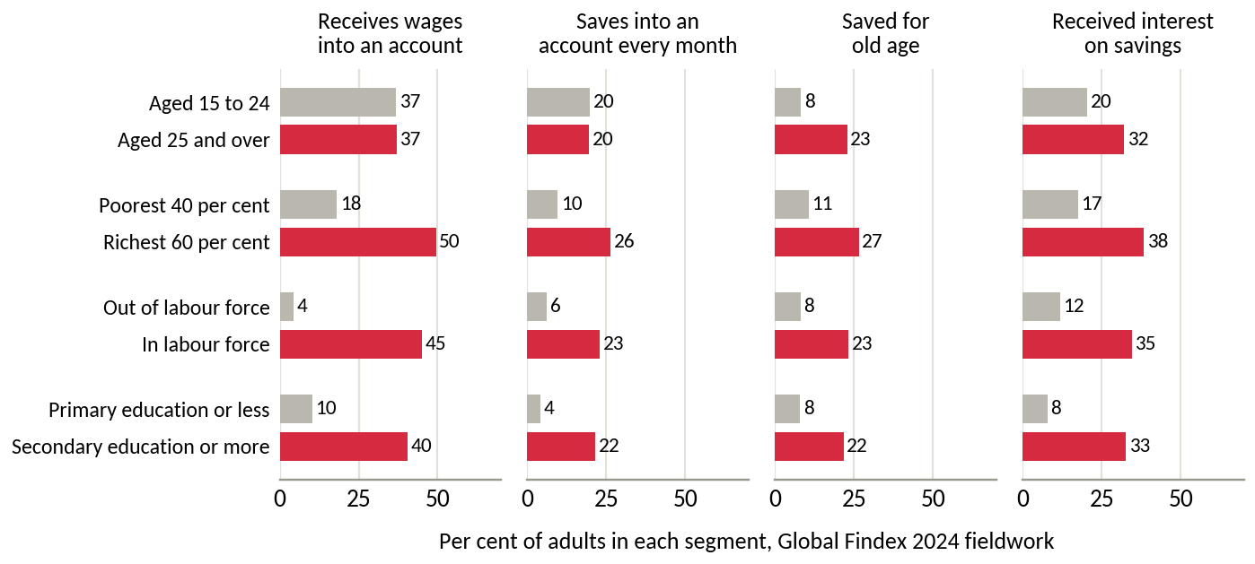
Figure E1. Payday and saving behaviour by segment pair
Source: World Bank (2025).
Table E3. Customer segments and objectives
Segment (E existing, N new) | Main barrier (hypothesis) | Objective
E1. Active and funded (85,739 active; 27,100 above VND 10 million) | Reliability; rivals' yields | Retain; add a goal
E2. Dormant intenders (about 1.4 million accounts below VND 10 million) | Procrastination; reward disputes | Launch target
N1. Salaried adults aged 22 to 40 (15 to 20 million account holders who do not save formally) | No route from salary to investment | Scale-up target
N2. First-time investors aged 15 to 24 | Low capital; irregular income | Build habits cheaply
N3. Older, wealthy investors | Prefer human brokers and bank brands | Deprioritise
Source: Sections 2.2 and 2.7; World Bank (2025). Sizes and barriers are hypotheses for internal data to test. KPMG Vietnam (2025) expects 68.2 per cent of households to earn more than USD 5,000 a year by 2028.

Appendix F. Assumptions, sensitivity and alternative explanations
Table F1. Register of assumptions and derived measures
Item | Type | Effect if wrong | How Round 3 tests it
Segment sizes and barriers (Table E3) | Hypothesis | Wrong target or message | DNSE internal data; Findex microdata; survey
Share of dormant accounts held by intenders | Hypothesis | Enrolment falls short | Test 1 (survey and internal data)
Automation and trust features raise funding | Hypothesis supported by research abroad | Concept fails the pilot | Tests 2 to 4
Scenario inputs (savers, contribution, retention, fee yield) | Assumption | Outcomes change in proportion | Pilot read-out at month 6
Platform cost proxy | Derived proxy | Level may be over- or understated; trend reliable | DNSE management accounts
Cost of funds for DNSE and peers | Derived | Line 24 may include more provisions than assumed | Notes on borrowing terms
Account counts differ in date and definition | Measured, mixed dates | Per-account values shift by up to about 10 per cent | Internal account register
App reviews are self-selected | Measured, biased sample | Levels overstate dissatisfaction; comparisons across themes and apps are more reliable | Complaint logs; customer survey
Gen Z share of DNSE accounts | External estimate | Weaker or stronger mismatch | DNSE demographic data
Regulatory feasibility | Assumption | Launch delayed | Test 5 (compliance review and SSC notice)
Source: authors.
Table F2. Alternative explanations tested
Explanation | Evidence | Verdict
The market cycle explains low balances | Assets per account fell 9.5% in 2025 while the VN-Index rose 41%; the 2026 cash outflow hit all brokers in similar proportion | Rejected
DNSE lacks capital to lend | Loans were 116% of equity against a 200% ceiling, leaving room for about VND 4.6 trillion more | Rejected
Every broker counts dormant accounts | Peers with similar account counts lend 5 to 12 times more per account | Rejected
Reliability alone deters funding | Reliability complaints are as common at VPS, which lends five times more per account | Partly rejected
DNSE acquires young customers now to earn from them later | Public data do not separate cohorts by year of account opening | Cannot be rejected; needs cohort data
Source: Sections 2 and 3; Appendix C.
Table F3. Never-Sleeping Account and Payday Portfolio
 | Never-Sleeping Account | Payday Portfolio
Job | Earns a return on cash already deposited | Brings new money in and invests it regularly
Customers | Active traders with idle cash (E1) | Salaried intenders who have not funded (E2, N1)
Trigger | Customer decides to deposit | Payday, automatically
Return | 1.8% base plus bonuses for large balances and trading value | Chosen bonds, funds and exchange-traded funds
Behavioural mechanism | None | Default, automation and goal tracking
Source: DNSE Securities (2026b); authors' design.
Table F4. Customer concerns, design responses and published proof
Customer concern (from reviews) | Design response | Published proof
Money cannot be withdrawn | Cash back to the linked bank 24/7; no closure fee | Median withdrawal time
Customers are locked in | Pause, skip or cancel in one tap, free of charge | Cancellations completed in the app
Conditions are hidden | All terms on one screen; rewards only on money that stays | Trust themes below 10% of negative reviews (37% since 2025)
Customers cannot see where money sits | Screen showing the segregated client account and securities held in the customer's name | Monthly statement
The app crashes | Transfers run as scheduled back-end jobs; reliability is a launch gate | Transfer success of 99.5% or more
The product may not be legal | Product notified to the SSC before launch | Written confirmation
Source: Appendix D; authors' design.
Table F5. Outcomes 18 months after launch (all inputs are assumptions)
 | Conservative | Base | Upside
Savers enrolled | 60,000 | 150,000 | 300,000
Monthly contribution, VND million | 1.0 | 1.5 | 2.5
Share of contributions kept | 60% | 70% | 80%
Assets, VND trillion (multiple of investor cash) | 0.65 (0.3) | 2.84 (1.4) | 10.80 (5.5)
Annual fees, VND billion | 3 | 23 | 108
Tier interest, upper bound, VND billion a year | 1.5 | 5.6 | 18.8
Accounts with VND 10 million or more (share of mid-2026 base) | 87,100 (5.1%) | 177,100 (10.4%) | 327,100 (19.2%)
Source: authors' projections (Appendix F1; Figure F1).
F1. Scenario method for Table F5. Assets per saver equal the monthly contribution times the share kept times 18 months, before investment returns (VND 10.8, 18.9 and 36.0 million). Payday Portfolio assets equal assets per saver times the number of savers. Annual fees apply a yield of 0.5, 0.8 and 1.0 per cent to assets, covering bond and fund distribution. The count of accounts holding VND 10 million or more adds the savers to the 27,100 accounts already above that level, assuming that savers start below VND 10 million and pass it within 18 months. The average conservative-case saver only just passes it, so that count is an upper bound. Shares divide by the mid-2026 base of 1.7 million accounts, so new sign-ups do not dilute them. The base case needs about one account in eleven to enrol, 1.75 times the customers active in December 2025. Costs of incentives, marketing and technology are estimated in Round 3 (test 7). The upper bound on tier interest assumes that every saver keeps one full month's contribution in the idle-cash account at 2.5 points above the base rate, the gap between 1.8 and 4.3 per cent. The comparison with sign-up rewards multiplies VND 100,000 by the 518,514 accounts opened in 2025. The investor-cash comparison in Section 3.2 divides industry investor cash of VND 86.6 trillion by 13.85 million accounts, which gives VND 6.25 million per account, against VND 1.15 million at DNSE.
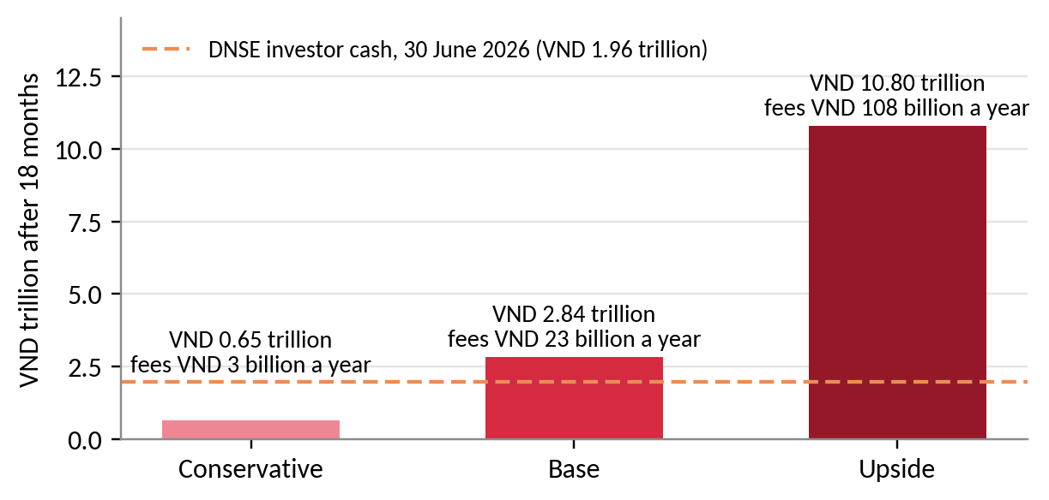
Figure F1. Payday Portfolio assets after 18 months under three scenarios
Source: Table F5.
F2. Validation direction. The headline KPI is the number of accounts holding VND 10 million or more, which DNSE already reports. It was 27,100 (1.8 per cent of accounts) at the end of 2025, and the target is 85,000 within 18 months, 5 per cent of the mid-2026 base. Supporting KPIs are the share of savers reaching three and six consecutive contributions, net new money, cost per funded account (VND 7.3 million today) and the trust share of negative reviews (37 per cent since 2025). Table F6 ranks the assumptions by the damage they would cause if wrong. DNSE should scale only if tests 1 to 4 pass and both gates hold. If enrolment falls short while retention holds, the message changes, and if retention fails, the concept stops (Figure F2).
Table F6. Priority assumptions, tests and thresholds for Round 3
# | Assumption | Test | Threshold to proceed
1 | Many dormant accounts belong to salaried intenders | Internal data; survey of 2,000 customers | 30% or more intend to invest
2 | Advised automation turns intention into funding | Randomised pilot with 20,000 customers | 15% enrol in 60 days; 70% of money kept at day 90
3 | Tiers and the skip month raise persistence | Pilot arms with and without tiers | Six-contribution rate up 10 points
4 | Trust features raise set-up | A/B test of the trust screen | Set-up completion up 5 points
5 | The advice flow is compliant (gate) | Compliance review; SSC notice | Written confirmation
6 | Transfers are reliable (gate) | Load tests; shadow payday runs | 99.5% transfer success
7 | Inflows are new money; unit costs fall | Tag inflow sources; track costs | 80% new money; cost below VND 7.3 million per funded account
Source: authors' design.
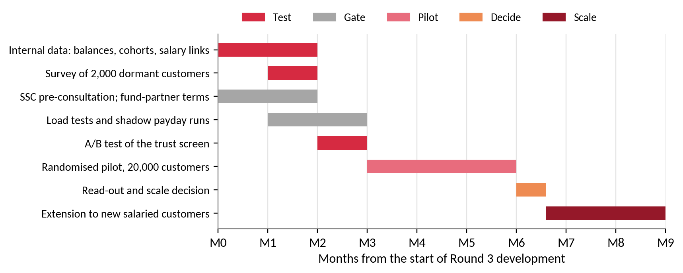
Figure F2. Validation roadmap for Round 3
Source: authors' design.

Appendix G. Regulatory basis and technology proposals
Table G1 records how each proposal was tested against the licensing and lending rules that apply to a securities company. The decisions define the scope of the first release in Section 4.
Table G1. Assessment of the proposed features and technology add-ons
Proposal | What it would do | Main constraint | Decision
Ensa suitability check and model portfolios | Records goal, horizon, income and risk tolerance; proposes one of three model portfolios | This is investment advice; Circular 121/2020, Article 24 requires this client information | Adopt inside DNSE's advisory licence; the customer confirms
Automatic rebalancing | Sells and buys to restore target weights | Article 4 bars investing on a client's behalf without a mandate; each sale incurs 0.1% tax | Adopt with new money only; changes confirmed in one tap
Paid membership tier | Monthly fee for extra features | Fees before any return repeat the terms that customers call deceptive | Replace with free tiers earned by contributions
ZaloPay round-up micro-investing | Rounds up wallet payments and invests the difference | Small amounts; needs ZaloPay's product work; funding of cashback unclear | Phase-2 test for young users
Ensa Smart Vaults via Lightspeed API | Algorithmic portfolios executed automatically for an asset-based fee | Portfolio management is outside a securities company's four licensed businesses (Law on Securities, Article 72); speed adds little for monthly savers | Set aside; possible later as funds from a licensed manager that DNSE distributes
Margin-on-Wealth credit line | Overdraft secured on Golden Egg, fund units and idle cash | Article 27 limits lending to margin and defined purposes; fund units are not listed securities; 2026 fine on unreported advance services | Reject
Margin Deal discount as a tier reward | Cheaper leverage after twelve contributions | Conflicts with a saver's goal and with the 2026 inspection findings | Exclude from rewards
Transparency dashboard and VNeID checks | Shows the segregated client account; faster identity checks | Needs a bank data feed; VNeID integration to be confirmed | Adopt the dashboard; test VNeID
Source: Ministry of Finance (2020); National Assembly (2019); Market Times (2026); DNSE Securities (2026d); authors' assessment.

REFERENCES
Ashraf, N., Karlan, D., & Yin, W. (2006). Tying Odysseus to the mast: Evidence from a commitment savings product in the Philippines. The Quarterly Journal of Economics, 121(2), 635-672. https://doi.org/10.1162/qjec.2006.121.2.635
Bao Dau Thau. (2026, September 3). CPI tháng 8/2026 tăng 0,47% [CPI rose 0.47% in August 2026]. https://baodauthau.vn/cpi-thang-82026-tang-047-post206275.html
CafeF. (2024, November 21). Công ty đứng sau thương vụ IPO duy nhất của thị trường Việt Nam năm 2024 [The company behind Vietnam's only IPO of 2024]. https://cafef.vn/cong-ty-dung-sau-thuong-vu-ipo-duy-nhat-cua-thi-truong-viet-nam-nam-2024-chu-tich-tung-la-ceo-tre-nhat-lich-su-vndirect-loi-nhuan-tang-truong-hon-100-lan-trong-4-nam-188241121113910237.chn
CafeF. (2026, July 22). Soi số lợi nhuận 15.200 tỷ của ngành chứng khoán trong quý 2 [The securities industry's VND 15,200 billion profit in Q2]. https://cafef.vn/soi-so-loi-nhuan-15200-ty-cua-nganh-chung-khoan-trong-quy-2-mot-cuoc-doi-ngoi-dang-am-tham-dien-ra-188260722020054991.chn
DNSE Securities. (2025). So sánh các chương trình "sinh lời tự động" từ tiền nhàn rỗi 2025 [Comparison of automatic-earning programmes for idle cash, 2025]. https://www.dnse.com.vn/hoc/chuong-trinh-sinh-loi-tu-dong
DNSE Securities. (2026a). Financial statements and investor relations releases, 2019 to the second quarter of 2026. https://ir.dnse.com.vn/vi/ctype-finance_report
DNSE Securities. (2026b). Tài khoản Không Ngủ [Idle-cash account, product page]. Retrieved September 24, 2026, from https://www.dnse.com.vn/san-pham/tai-khoan-khong-ngu
DNSE Securities. (2026c). Báo cáo thường niên 2025 [Annual report 2025]. https://cdn.dnse.com.vn/dnse-assets/CBTT/DSE%20-%20BCTN%202025.pdf
DNSE Securities. (2026d). Điều khoản và điều kiện sản phẩm "Ý Tưởng Đầu Tư" [Terms and conditions of the Investment Ideas product]. Retrieved September 27, 2026, from https://hdsd.dnse.com.vn/die-u-khoa-n-di-ch-vu-dnse/dieu-khoan-san-pham-dich-vu/dieu-khoan-va-dieu-kien-san-pham-y-tuong-dau-tu
DNSE Securities. (2026e). Lightspeed API [Product page]. Retrieved September 27, 2026, from https://www.dnse.com.vn/lightspeed-api
Hanoi Stock Exchange. (2026). Quarterly announcements of the ten securities companies with the largest brokerage market share, Q4 2017 to Q2 2026 [Data set]. Retrieved September 25, 2026, from https://www.hnx.vn
Kahneman, D., & Tversky, A. (1979). Prospect theory: An analysis of decision under risk. Econometrica, 47(2), 263-291. https://doi.org/10.2307/1914185
KPMG Vietnam. (2025). Vietnam 2026 outlook. https://assets.kpmg.com/content/dam/kpmgsites/vn/pdf/2025/10/vietnam-2026-outlook.pdf
Madrian, B. C., & Shea, D. F. (2001). The power of suggestion: Inertia in 401(k) participation and savings behavior. The Quarterly Journal of Economics, 116(4), 1149-1187. https://doi.org/10.1162/003355301753265543
Market Times. (2026, August 17). Chứng khoán DNSE (DSE) của Chủ tịch Nguyễn Hoàng Giang bị phạt hơn 800 triệu đồng vì loạt vi phạm trong hoạt động chứng khoán [DNSE fined more than VND 800 million for securities violations]. https://markettimes.vn/chung-khoan-dnse-dse-cua-chu-tich-nguyen-hoang-giang-bi-phat-128642.html
Ministry of Finance. (2020). Circular No. 121/2020/TT-BTC on the operation of securities companies. https://thuvienphapluat.vn/van-ban/Doanh-nghiep/Thong-tu-121-2020-TT-BTC-huong-dan-hoat-dong-cua-cong-ty-chung-khoan-453690.aspx
National Assembly of Vietnam. (2019). Law on Securities No. 54/2019/QH14. https://thuvienphapluat.vn/van-ban/Chung-khoan/Luat-Chung-khoan-nam-2019-399763.aspx
Nhan Dan. (2025, July 8). Công bố khảo sát 2025 về nhu cầu quản lý tài sản và đầu tư của người Việt [2025 survey of Vietnamese wealth management and investment needs]. https://nhandan.vn/cong-bo-khao-sat-2025-ve-nhu-cau-quan-ly-tai-san-va-dau-tu-cua-nguoi-viet-post892406.html
O'Donoghue, T., & Rabin, M. (1999). Doing it now or later. American Economic Review, 89(1), 103-124. https://doi.org/10.1257/aer.89.1.103
Phu Nu Viet Nam. (2026, August 19). Công ty Chứng khoán DNSE bị buộc dừng cung cấp dịch vụ tài chính [DNSE ordered to stop providing financial services]. https://phunuvietnam.vn/cong-ty-chung-khoan-dnse-bi-buoc-dung-cung-cap-dich-vu-tai-chinh-238260818165854342.htm
State Bank of Vietnam. (2024). Circular No. 64/2024/TT-NHNN on the implementation of open application programming interfaces in the banking sector.
TCBS. (2026). iPower [Product page]. Retrieved September 24, 2026, from https://www.tcbs.com.vn/ca-nhan/san-pham/ipower/
Thaler, R. H., & Benartzi, S. (2004). Save More Tomorrow: Using behavioral economics to increase employee saving. Journal of Political Economy, 112(S1), S164-S187. https://doi.org/10.1086/380085
Thanh Nien. (2023, July 17). ZaloPay hợp tác DNSE để trở thành ví điện tử hỗ trợ đầu tư chứng khoán [ZaloPay partners with DNSE to support securities investment]. https://thanhnien.vn/zalopay-hop-tac-dnse-de-tro-thanh-vi-dien-tu-ho-tro-dau-tu-chung-khoan-185230717103958115.htm
Thanh Nien. (2025, December 31). VN-Index kết thúc năm 2025 với mức tăng khủng gần 41% [The VN-Index ends 2025 up almost 41%]. https://thanhnien.vn/vn-index-ket-thuc-nam-2025-voi-muc-tang-khung-gan-41-185251231154434459.htm
Thuong Hieu & Cong Luan. (2024). Công ty Cổ phần Chứng khoán DNSE bị xử phạt 125 triệu đồng [DNSE fined VND 125 million]. https://thuonghieucongluan.com.vn/cong-ty-co-phan-chung-khoan-dnse-bi-xu-phat-125-trieu-dong-a243582.html
Vietcap Securities. (2026). Financial statements of DSE and other securities companies, Q1 2018 to Q2 2026 [Data set]. Vietcap IQ. Retrieved September 24, 2026, from https://iq.vietcap.com.vn
VietnamNet. (2026, September 9). Lãi suất ngân hàng hôm nay 9/9/2026 [Bank interest rates on 9 September 2026]. https://vietnamnet.vn/lai-suat-ngan-hang-hom-nay-9-9-2026-lai-suat-ngan-hang-big4-len-den-8-nam-2553329.html
Vietstock. (2026a, March 26). Những nội dung đáng chú ý ở ĐHĐCĐ thường niên DNSE 2026 [Highlights of DNSE's 2026 AGM]. https://vietstock.vn/2026/03/nhung-noi-dung-dang-chu-y-o-dhdcd-thuong-nien-dnse-2026-737-1415846.htm
Vietstock. (2026b, June 2). Sự trỗi dậy của các công ty chứng khoán thuộc ngân hàng [The rise of bank-owned securities companies]. https://vietstock.vn/2026/06/su-troi-day-cua-cac-cong-ty-chung-khoan-thuoc-ngan-hang-757-1449465.htm
Vietstock. (2026c, July 21). Dư nợ margin lập kỷ lục 454 ngàn tỷ đồng, cuộc đua có sự phân hóa [Margin lending reaches a record VND 454 trillion]. https://vietstock.vn/2026/07/du-no-margin-lap-ky-luc-454-ngan-ty-dong-cuoc-dua-co-su-phan-hoa-830-1468883.htm
VnEconomy. (2025, July 8). Lời giải nào cho nghịch lý giữa kỳ vọng sinh lời và tâm lý e ngại của nhà đầu tư Việt? [Resolving the paradox between Vietnamese investors' return expectations and caution]. https://vneconomy.vn/loi-giai-nao-cho-nghich-ly-giua-ky-vong-sinh-loi-va-tam-ly-e-ngai-cua-nha-dau-tu-viet.htm
VnEconomy. (2026, July 22). Lãi suất cao khiến số dư tiền gửi của nhà đầu tư tại công ty chứng khoán giảm về mức thấp nhất 1 năm? [High interest rates push investor deposits at brokers to a one-year low]. https://vneconomy.vn/lai-suat-cao-khien-so-du-tien-gui-cua-nha-dau-tu-tai-cong-ty-chung-khoan-giam-ve-muc-thap-nhat-1-nam.htm
VnExpress. (2025, July 21). Cách DNSE thu hút khách hàng gen Z [How DNSE attracts Gen Z customers]. https://vnexpress.net/cach-dnse-thu-hut-khach-hang-gen-z-4916725.html
VnExpress. (2026a, September 10). Người Việt mở thêm 2 triệu tài khoản chứng khoán sau 8 tháng [Vietnamese open 2 million more securities accounts in eight months]. https://vnexpress.net/nguoi-viet-mo-them-2-trieu-tai-khoan-chung-khoan-sau-8-thang-5118477.html
VnExpress. (2026b, September 23). Thêm nhiều ngân hàng trả lãi tiết kiệm trên 9% [More banks pay savings rates above 9%]. https://vnexpress.net/them-nhieu-ngan-hang-tra-lai-tiet-kiem-tren-9-5123534.html
World Bank. (2025). Global Financial Inclusion (Global Findex) database 2025, Vietnam [Data set]. World Bank Open Data. Retrieved September 20, 2026, from https://api.worldbank.org/v2/sources/28/country/VNM/series/all/data?format=json

